Supplemental appendices
Chapter 3
Table A3.1: Countries in the regional survey samples
Country name | Income group | IMF program | Initial IMF conditions in program | Agreement date of IMF program | Survey date(s) | Dates of most recent incumbent change (before survey date) | Election winner
Afrobarometer
Botswana | Non-HIC | --- |  |  | 15/04/1999 | 31/03/1998 | Festus Gontebanye Mogae (BDP)
Ghana | Non-HIC | PR/95/38 (ESAF) | 43 | 30/06/1995 (36 months) | 16/04/1999 | 07/01/1993 | Jerry John Rawlings (NDC)
Lesotho | Non-HIC | PR/96/48 (SBA) | 27 | 23/09/1996 (12 months) | 15/04/2000 | 29/05/1998 | Pakalitha Mosisili (LCD)
Mali | Non-HIC | PR/96/14 (ESAF) | 26 | 10/04/1996 (36 months) | 14/01/2001-15/04/2001 | 08/06/1992 | Alpha Oumar Konaré (ADEMA-PASJ)
Malawi | Non-HIC | PR/95/54 (ESAF) | 38 | 18/10/1995 (36 months) | 15/04/1999 | 21/05/1994 | Elson Bakili Muluzi (UDF)
Namibia | Non-HIC | --- |  |  | 15/04/1999 | 21/03/1990 | Samuel Daniel Nujoma (SWAPO)
Nigeria | Non-HIC | --- |  |  | 15/04/1999 | 29/05/1999 | Olusegun Obasanjo (PDP)
Tanzania | Non-HIC | PR/96/55 (ESAF) | 18 | 08/11/1996 (36 months) | 15/04/2001 | 23/11/1995 | Benjamin William Mkapa (CCM)
Uganda | Non-HIC | PR/97/52 (ESAF) | 16 | 10/11/1997 (36 months) | 01/04/2000-16/04/2000 | 26/01/1986 | Yoweri Kaguta Museveni (NRM)
South Africa | Non-HIC | --- |  |  | 14/04/2000-01/10/2000 | 16/06/1999 | Thabo Mvuyelwa Mbeki (ANC)
Zambia | Non-HIC | PR/95/62 (ESAF) | 10 | 06/12/1995 (36 months) | 16/04/1999 | 02/11/1991 | Frederick J. T. Chiluba (MMD)
Zimbabwe | Non-HIC | PR/98/20 (SBA) | 26 | 01/06/1999 (14 months) | 16/04/1999 | 31/12/1987 | Robert Gabriel Mugabe (ZANU-PF)
Asian Barometer
Indonesia | Non-HIC | PR/00/4 (EFF) | 30 | 04/02/2000 (36 months) | 11/2006 | 23/07/2001 | Megawati Sukarnoputri (PDIP)
Mongolia | Non-HIC | PR/01/42 (PRGF) | 28 | 28/09/2001 (36 months) | 05-06/2006 | 20/06/1997 | Natsagiyn Bagabandi (MAKN)
Vietnam | Non-HIC | PR/01/12 (PRGF) | 46 | 16/04/2001 (36 months) | 11-12/2005 | 24/09/1997 | Tran Duc Luong (DCV)
Cambodia | Non-HIC | --- |  |  | 04-05/2008 | 30/11/1998 | Hun Sen (KPK)
China | Non-HIC | --- |  |  | 11-12/2008 | 15/11/2002 | Hu Jintao (CCP)
Hong Kong | HIC | --- |  |  | 09-11/2007 | 21/06/2005 | Donald Tsang Yam-kuen
Japan | HIC | --- |  |  | 02-03/2007 | 26/06/2006 | Shinzo Abe (LDP)
Malaysia | Non-HIC | --- |  |  | 07-10/2007 | 31/10/2003 | Datuk Seri Abdullah Ahmad Badawi (UMNO)
Philippines | Non-HIC | --- |  |  | 11-12/2005 | 20/01/2001 | Maria Gloria Macapagal Arroyo (Lakas-KAMPI-CMD)
Singapore | HIC | --- |  |  | 07-11/2006 | 01/09/1999 | Sellapan Ramanathan Nathan (PAP)
South Korea | Non-HIC | --- |  |  | 09/2006 | 25/02/2003 | Roh Moo Hyun (MDP/UD)
Taiwan | HIC | --- |  |  | 01-02/2006 | 20/05/2000 | Chen Shui-bian (MCT)
Thailand | Non-HIC | --- |  |  | 04-09/2006 | 19/09/2006 | Thaksin Shinawatra (TRT)
Latinobarometer
Argentina | Non-HIC | PR/03/160 (SBA) | 36 | 20/09/2003 (36 months) | 01/08/2005-10/09/2005 | 25/05/2003 | Néstor Carlos Kirchner Ostoic (PJ/FPV)
Bolivia | Non-HIC | PR/03/46 (SBA) | 45 | 02/04/2003 (12 months) | 01/08/2005-10/09/2005 | 17/10/2003 | Carlos Diego Mesa Gisbert (non-partisan)
Brazil | Non-HIC | PR/02/40 (SBA) | 30 | 06/09/2002 (15 months) | 01/08/2005-10/09/2005 | 01/01/2003 | Luiz Inácio Lula da Silva (PT)
Colombia | Non-HIC | PR/03/4 (SBA) | 21 | 15/01/2003 (24 months) | 01/08/2005-10/09/2005 | 07/08/2002 | Álvaro Uribe Vélez (PL)
Dominican Republic | Non-HIC | PR/03/147 (SBA) | 27 | 29/08/2003 (24 months) | 01/08/2005-10/09/2005 | 16/08/2004 | Leonel Antonio Fernández Reyna (PLD)
Ecuador | Non-HIC | PR/03/39 (SBA) | 62 | 21/03/2003 (13 months) | 01/08/2005-10/09/2005 | 15/01/2003 | Lucio Edwin Gutiérrez Borbúa (PSP)
Guatemala | Non-HIC | PR/03/90 (SBA) | 24 | 18/06/2003 (9 months) | 01/08/2005-10/09/2005 | 15/01/2004 | Óscar Rafael Berger Perdomo (GANA)
Honduras | Non-HIC | PR/04/29 (PRGF) | 50 | 27/02/2004 (36 months) | 01/08/2005-10/09/2005 | 27/01/2002 | Ricardo Rodolfo Maduro Joest (PNH)
Nicaragua | Non-HIC | PR/02/53 (PRGF) | 13 | 13/12/2002 (36 months) | 01/08/2005-10/09/2005 | 10/01/2002 | Enrique José Bolaños Geyer (PLC)
Panama | Non-HIC | EBM/00/65 (SBA) | 18 | 30/06/2000 (21 months) | 01/08/2005-10/09/2005 | 01/09/2004 | Martín Erasto Torrijos Espino (PRD)
Peru | Non-HIC | PR/04/112 (SBA) | 20 | 09/06/2004 (26 months) | 01/08/2005-10/09/2005 | 28/07/2001 | Alejandro Celestino Toledo Manrique (PP)
Paraguay | Non-HIC | PR/03/218 (SBA) | 17 | 15/12/2003 (15 months) | 01/08/2005-10/09/2005 | 15/08/2003 | Óscar Nicanor Duarte Frutos (ANR)
Chile | HIC | --- |  |  | 01/08/2005-10/09/2005 | 11/03/2000 | Ricardo Froilán Lagos Escobar (PPD/PS/CPD)
Costa Rica | Non-HIC | --- |  |  | 01/08/2005-10/09/2005 | 08/05/2002 | Abel Pacheco de la Espriella (PUSC)
El Salvador | Non-HIC | --- |  |  | 01/08/2005-10/09/2005 | 01/06/2004 | Elías Antonio Saca González (ARENA)
Mexico | Non-HIC | --- |  |  | 01/08/2005-10/09/2005 | 01/12/2000 | Vicente Fox Quesada (PAN)
Uruguay | HIC | --- |  |  | 01/08/2005-10/09/2005 | 01/03/2005 | Tabaré Ramón Vázquez Rosas (PSU/EP-FA-NM, PSU/FA)
Venezuela | Non-HIC | --- |  |  | 01/08/2005-10/09/2005 | 14/04/2002 | Hugo Rafael Chávez Frías (MVR/PSUV)
Notes: Data on survey dates drawn from Afrobarometer (https://www.afrobarometer.org/surveys-and-methods/survey-resources/?hidden-current-page=1&current-page=57#listing), Asian Barometer (http://www.asianbarometer.org/survey/survey-timetable), and Latinobarometro (https://www.latinobarometro.org/latContents.jsp). Data on IMF programs drawn from the IMF Monitor (Kentikelenis, Stubbs, and King 2016). IMF programs are considered relevant if their agreement date is within the five-year period before the survey date. Data on election results and incumbent presidents from Zarate dataverse (Zárate 2022).

Table A3.2: Descriptive statistics for variables in the Afrobarometer sample
Variable name | Variable definition | Obs | Mean | Sd | Min | Max
Protest | Binary indicator based on Afrobarometer question (pardem): “Here are a number of different actions people might take if government were to do something they thought was wrong or harmful. For each of these, please tell me whether you have engaged in this activity or not: Attend a demonstration or protest march?”  Answer categories included:  “Yes, often”  “Yes, a few times”  “Yes, once or twice”  “No, but would do it if had the chance”  “No, would never do this”  “Don’t know”  The question notes suggest that respondents were asked to indicate protest activity over a five-year horizon. To construct the dummy, we combined the first three response categories. Individuals who said “don’t know” are dropped. | 16692 | 0.133 | 0.339 | 0 | 1
Protest inclination | Binary indicator based on Afrobarometer question (pardem): “Here are a number of different actions people might take if government were to do something they thought was wrong or harmful. For each of these, please tell me whether you have engaged in this activity or not: Attend a demonstration or protest march?”  Answer categories included:  “Yes, often”  “Yes, a few times”  “Yes, once or twice”  “No, but would do it if had the chance”  “No, would never do this”  “Don’t know”  To construct the dummy, we combined the first four response categories. Individuals who said “don’t know” are dropped. | 19085 | 0.242 | 0.428 | 0 | 1
SAP made my life worse | Binary indicator based on Afrobarometer question (sapsat): “What effect do you think [your country’s SAP] has had on the way you live your life: Has it made it worse, had no effect, or made it better, or haven’t you heard enough about this to say?”  Answer categories included:  “Made it a lot worse”  “Made it worse”  “Had no effect”  “Made it better”  “Made it a lot better”  “Don’t know/Haven’t had a chance to hear”  To construct the dummy, we combined the two negative response categories. | 17971 | 0.220 | 0.414 | 0 | 1
Deprivation index | Additive index based on Afrobarometer questions of the following kind: “In the last twelve months, how often have you or your family: [marker of deprivation]”, with answer categories ‘never’ (1), ‘rarely’ (2), ‘sometimes’ (3), and ‘often’ (4), in addition to non-responses. As markers of deprivation, we consider food (povfoo), clean water (povwat), health services (povhth), and income (povinc). We construct the index by computing povfoo+povwat+povinc+povhth-4 | 13417 | 3.419 | 2.201 | 0 | 11
Public-sector worker | Binary indicator based on the Afrobarometer question (occup): “What is your present occupation or last occupation if unemployed?” Among the answer categories were:  10: Teacher  11: Government worker  17: Politician  20: Security worker  48: Armed forces  To construct the dummy, we combine the responses from all above categories. | 21531 | 0.048 | 0.213 | 0 | 1
IMF program | Binary indicator for whether the country is under an IMF program in the year before the survey (Table A3.1 shows the survey years for African countries). Data on IMF programs are from the IMF Monitor Database (Kentikelenis, Stubbs, and King 2016). | 21531 | 0.303 | 0.459 | 0 | 1
Conditionality | Number of binding conditions (BA2TOT) in the year preceding the survey provided there was an ongoing IMF program. Table A3.1 provides information on the survey years. Data on conditions are drawn from the IMF Monitor Database (Kentikelenis, Stubbs, and King 2016). | 21531 | 19.408 | 18.078 | 0 | 44
Opposition supporter | Binary indicator based on an Afrobarometer variable (pidwin) combining information on which party the respondent voted for in the last election and information about which party was in power after the election (constructed by Afrobarometer). The dummy takes the value of one for individuals who voted for the losing party, and zero for those who supported the winning party. Non-partisan individuals have a missing value. | 11192 | 0.303 | 0.460 | 0 | 1
Male | To construct the dummy, we utilized “male” response category from the Afrobarometer question gender | 21531 | 0.499 | 0.500 | 0 | 1
Age (logged) | Natural logarithm of age computed from Afrobarometer question (age): “How old were you at your last birthday?” If respondent couldn’t answer, the question was: “In which year were you born?” | 21107 | 3.518 | 0.376 | 2.71 | 4.61
Urban resident | Binary indicator based on Afrobarometer variable coded by interview. To construct the dummy, we utilized “urban” category only. | 21531 | 0.433 | 0.496 | 0 | 1
Unemployed | Binary indicator based on the Afrobarometer question (occup): “What is your present occupation or last occupation if unemployed?” To construct the dummy, we utilized “unemployed/applicant” category only. | 21531 | 0.030 | 0.171 | 0 | 1
Educated | Binary indicator based on the Afrobarometer question (educ): “What was the highest grade, standard or form you completed?”  Answer categories included:  “No formal schooling”  “Primary only”  “Secondary”  “Post-secondary”  “Don’t know”  To construct the dummy, we utilized answer category “Post-secondary”. | 21443 | 0.354 | 0.479 | 0 | 1
Radio listener | Binary indicator based on Afrobarometer question (medrad): “How often do you get news from the following sources: radio?”  Answer categories included:  “Every day”  “A few times a week”  “A few times a month”  “Less than once a month”  “Never”  “Don’t know”  To construct the dummy, we combined the first two responses categories. | 21531 | 0.282 | 0.450 | 0 | 1
Politically interested | Binary indicator based on Afrobarometer question (scint): “Some people seem to follow what’s going on in government and public affairs most of the time, whether there’s an election going on or not. Others aren’t that interested. Would you say you follow what’s going on in government and public affairs:  “Always or most of the time”  “Some of the time”  “Only now and then”  “Hardly at all”  “Don’t know”  time, only now and then, hardly at all, don’t know.  To construct the dummy, we utilized the first response category only. | 21531 | 0.240 | 0.427 | 0 | 1
Politically knowledgeable | Binary indicator based on Afrobarometer question (sckfin): “Now let us speak about the political system in this country. First of all, can you tell me who presently holds the following position: the Minister of Finance?”  Answer categories included:  “Right answer”  “Wrong answer”  “Couldn’t determine”  To construct the dummy, we utilized “right answer” only. | 21531 | 0.204 | 0.403 | 0 | 1
Democracy supporter | Binary indicator based on Afrobarometer question (supdem): “With which one of these statements are you most in agreement? A, B or C?  A. Democracy is preferable to any other kind of government.  B. In some circumstances, a non-democratic government can be preferable to democratic government.  C. For someone like me, a democratic or non-democratic regime makes no difference.”  To construct the dummy, we use category A. | 21531 | 0.700 | 0.458 | 0 | 1
Satisfied with democracy | Binary indicator based on Afrobarometer question (satdem): “Overall, how satisfied are you with the way democracy works in [you country]?”  Answer categories included:  “Very satisfied.”  “Fairly satisfied.”  “Not very satisfied.”  “Not at all satisfied.”  “[Your country] is not a democracy.”  “Don’t know.”  To construct the dummy, we combine the positive response categories. | 21531 | 0.409 | 0.492 | 0 | 1
Prefers free market | Binary indicator based on Afrobarometer question (spamar): “Here are several more pairs of statements. Please tell me whether you most agree with Statement A or Statement B.  Statement A: It is better to have a wide variety of good and many goods in the market, even if prices are high.  Statement B: It is better to have low prices, even if there are shortages of goods.  Answer categories included:  “A, agree somewhat.”  “A, agree strongly.”  “B, agree somewhat.”  “B, agree strongly.”  “Don’t know.”  “Do not agree with either.”  To construct the dummy, we combine the positive response categories. | 21531 | 0.561 | 0.496 | 0 | 1
Supports capitalism | Binary indicator taken from Afrobarometer question (marear): “Here are several pairs of statements. Please tell me whether you most agree with Statement A or Statement B?  Statement A: People should be free to earn as much as they can, even if this leads to large differences in income.  Statement B: Government should place limits on how much rich people can earn, even if this discourages some people from working hard.”  Answer categories included:  “A, Agree somewhat”  “A, Agree strongly”  “B, Agree somewhat”  “B, Agree strongly”  “Don’t know”  “Do not agree with either”  To construct the dummy, we combine the positive response categories. | 21531 | 0.632 | 0.482 | 0 | 1
Supports public sector | Binary indicator taken from Afrobarometer question (sparet): “Here are several more pairs of statements. Please tell me whether you most agree with Statement A or Statement B.  Statement A: The number of people who work for government should not be reduced, even if paying their salaries is costly to the country.  Statement B: The government cannot afford so many public employees and should lay off/retrench some of them.”  Answer categories included:  “A, Agree somewhat”  “A, Agree strongly”  “B, Agree somewhat”  “B, Agree strongly”  “Don’t know”  “Do not agree with either”  To construct the dummy, we combine the positive response categories. | 21531 | 0.592 | 0.491 | 0 | 1
Supports privatization | Binary indicator taken from Afrobarometer question (sprprv): “Here are several more pairs of statements. Please tell me whether you most agree with Statement A or Statement B.  Statement A: The government should retain ownership of its factories, businesses, and farms.  Statement B: It is better for the government to sell its businesses to private companies and individuals.”  Answer categories included:  “A, Agree somewhat”  “A, Agree strongly”  “B, Agree somewhat”  “B, Agree strongly”  “Don’t know”  “Do not agree with either”  To construct the dummy, we combine the positive response categories. | 21531 | 0.581 | 0.493 | 0 | 1
Worse now than 12 months ago | Binary indicator taken from Afrobarometer question (pfepas): “How do economic conditions in [your country] now compared to one year ago? Are they:  “Much worse”  “Worse”  “About the same”  “Better”  “Much better”  “Don’t know”  To construct the dummy, we combine the negative response categories. | 21531 | 0.420 | 0.494 | 0 | 1
Worse in 12 months | Binary indicator taken from Afrobarometer question (pfefut): “What about in 12 months time? Do you expect economic conditions in [your country] to be worse, the same, or better than they are now?  “Much worse”  “Worse”  “About the same”  “Better”  “Much better”  “Don’t know”  To construct the dummy, we combine the negative response categories. | 21531 | 0.254 | 0.435 | 0 | 1
Dissatisfied with president | Binary indicator taken from Afrobarometer question (pfegre): “What about the way [president of your country] has performed his job over the past 12 months. Do you:  “Strongly disapprove”  “Disapprove”  “Approve”  “Strongly approve”  “Haven’t heard enough about [him] to know”  To construct the dummy, we combine the negative response categories. | 21531 | 0.191 | 0.393 | 0 | 1
Heard about IMF SAP | Binary indicator taken from Afrobarometer question (sapknw): “Have you heard anything about the government’s [country’s structural adjustment program] or haven’t you had a chance to hear or read about this yet?  Answer categories included:  “No”  “Yes”  “Don’t know”  To construct the dummy, we utilize the affirmative response category. | 21531 | 0.338 | 0.473 | 0 | 1

Table A3.3: Descriptive statistics for variables in the Asian Barometer sample
Variable label | Variable definition | Obs | Mean | Sd | Min | Max
Protest | Binary indicator for protest behavior based on Asian Barometer item (Q88): Attended a demonstration or protest march, with answer categories including once, more than once, never, no answer. To construct the dummy, we combine the once and more than once categories. | 15693 | 0.031 | 0.174 | 0 | 1
Government is biased | Perception of unequal treatment by government based on Asian Barometer item (Q108): Everyone is treated equally by the government—answer categories include (1) Strongly agree, (2) Somewhat agree, (3) Somewhat disagree, (4) Strongly disagree, and no answer. To construct the dummy, we combine answers (3) and (4). | 18211 | 0.374 | 0.484 | 0 | 1
Bad impression of IMF | Bad impression about the IMF based on Asian Barometer question (Q163) asking respondents about their impression of a range of foreign policy actors. Answers fall on a 1-10 scale from very bad to very good. To construct the dummy, we combine answers 1-4. Defined only for those heard about IMF. | 5071 | 0.102 | 0.302 | 0 | 1
Average conditionality | Average number of IMF conditions in the time frame (t-3, t-2, t-1) prior to survey year. There would have been no exposure to an IMF program with a one-lagged indicator. Information on conditionality based on IMF Monitor (Kentikelenis, Stubbs, and King 2016) | 18211 | 1.728 | 4.133 | 0 | 13.667
IMF exposure | Macro-level sample selection indicator for countries with any experience of an IMF program in the time frame (t-3, t-2, t-1) relative to the survey year. Information on IMF program status are based on IMF Monitor (Kentikelenis, Stubbs, and King 2016) | 18211 | 0.220 | 0.414 | 0 | 1
Opposition supporter | Partisan alignment with opposition indicator based on Asian Barometer variable whether respondent supported the losing party in the last election (Q39a)—missing for people who did not vote | 9232 | 0.363 | 0.481 | 0 | 1
Male | Binary indicator for whether respondent is male | 18211 | 0.495 | 0.500 | 0 | 1
(Logged) age | (Logged) age of the respondent (se3a) | 18204 | 3.125 | 0.741 | 0 | 4.407
Urban resident | Binary indicator for whether respondent lives in an urban area (Level3) | 18211 | 0.526 | 0.499 | 0 | 1
Employed | Binary indicator for whether respondent is employed based on question on occupation (se12a). We combine any form of employment mentioned. | 18211 | 0.477 | 0.499 | 0 | 1
Education | (Logged) number of years of education (se5a) | 14590 | 2.540 | 0.822 | 0.693 | 3.466
Supports democracy | Support for democracy indicator based on Asian Barometer question (Q121): Which of the following statements comes closest to your own opinion?  (1) For people like me, it does not matter whether we have a democratic or a nondemocratic regime,  (2) Under some circumstances, an authoritarian government can be preferable to a democratic one,  (3) Democracy is always preferable to any other kind of government.  To construct the dummy, we use the third category. | 18211 | 0.570 | 0.495 | 0 | 1
Democracy over growth | Priority for democracy indicator based on Asian Barometer question (Q123): If you had to choose between democracy and economic development, which would you say is more important?  (1) Economic development is definitely more important  (2) Economic development is somewhat more important  (3) Democracy is somewhat more important  (4) Democracy is definitely more important  (5) They are both equally important  To construct the dummy, we combine answers (3) and (4) | 18211 | 0.182 | 0.386 | 0 | 1
Economy got worse | Retrospective evaluation of the economy based on Asian Barometer question (Q2): How would you describe the change in the economic condition of our country over the last years? Answer categories include much worse, worse, about the same, better, much better, and missing. We combine much worse and worse to construct the indicator. | 18211 | 0.197 | 0.398 | 0 | 1
Must obey government | Obedience with government indicator based on Asian Barometer question (Q134): Government leaders are like the head of a family; we should all follow their decisions. Answer categories fall on a forced-choice four-point Likert scale. We combine agree and strongly agree to construct the indicator. | 18211 | 0.601 | 0.490 | 0 | 1
Supports majority rule | Government legitimacy based on Asian Barometer question (Q72): If a government policy serves the interests of the majority of people, I should support it. Answer categories fall on a forced-choice four-point Likert scale. We combine agree and strongly agree to construct the indicator. | 18211 | 0.575 | 0.494 | 0 | 1
Politically interested | Political interest indicator based on Asian Barometer question (Q49): How interested would you say you are in politics? (1) Not at all interested, (2) Not very interested, (3) Somewhat interested, (4) Very interested, no answer. To construct the dummy, we combine answers (3) and (4). | 18211 | 0.470 | 0.499 | 0 | 1
Politically informed | News media consumption indicator based on Asian Barometer question (Q50): How often do you follow news about politics and government? Answers include never, once a week, once or twice a week, several times, and every day. We use the last option to construct the dummy. | 18211 | 0.421 | 0.494 | 0 | 1
Heard about IMF | Binary indicator for whether respondent has heard about the IMF (Q159) | 18211 | 0.315 | 0.465 | 0 | 1

Table A3.4: Descriptive statistics for variables in the Latinobarometer sample
Variable label | Variable definition | Obs | Mean | Sd | Min | Max
Public education worsened | Binary indicator based on question: Would you say that in [country], in the last 12 months, the quality of the public school has gone down, gone up or stayed the same? (P90STB)  [1] Has gone up a lot  [2] Has gone up a little  [3] Has stayed the same  [4] Has gone down a little  [5] Has gone down a lot  [8] Don't know  We collapse answers [4] and [5] to capture worsening quality of public education. | 19558 | 0.215 | 0.411 | 0 | 1
Dissatisfied with public education | Would you say that you are very satisfied, rather satisfied,  not very satisfied or not at all satisfied with: Your access to  education (P91STB)  [1] Very satisfied  [2] Rather satisfied  [3] Not very satisfied  [4] Not at all satisfied  [0] No Answer  We use answers [3] and [4] to construct the dummy. | 20222 | 0.444 | 0.497 | 0 | 1
Public health services worsened | Binary indicator based on question: Would you say that in [country], in the last 12 months, the quality of public hospitals has gone down, gone up or stayed the same? (P90STA)  [1] Has gone up a lot  [2] Has gone up a little  [3] Has stayed the same  [4] Has gone down a little  [5] Has gone down a lot  [8] Don't know  We collapse answers [4] and [5] to capturing worsening quality of public health services. | 19662 | 0.292 | 0.455 | 0 | 1
Dissatisfied with public health services | Would you say that you are very satisfied, rather satisfied,  not very satisfied or not at all satisfied with: Your access to health (P91STA)  [1] Very satisfied  [2] Rather satisfied  [3] Not very satisfied  [4] Not at all satisfied  [0] No Answer  We use answers [3] and [4] to create the dummy. | 20222 | 0.481 | 0.500 | 0 | 1
Protest | Binary indicator based on any participation in the following types of political behavior, based on survey question: Please tell me whether you have engaged in any of these activities or not in the past twelve months:  Attend demonstration or protest march? (p72sta)  ⧠ Yes, have done  ⧠ Yes, could do  ⧠ No, would never do  Participate in riots? (p72stb)  ⧠ Yes, have done  ⧠ Yes, could do  ⧠ No, would never do  Taking part in unauthorized demonstrations (p72ste)  ⧠ Yes, have done  ⧠ Yes, could do  ⧠ No, would never do  Our binary indicator is one if any of these is answered affirmatively using “yes, have done” only. | 20222 | 0.140 | 0.348 | 0 | 1
Opposition supporter (based on partisan allegiance) | Binary indicator for opposition supporter based on two pieces of information: 1) Survey question: Where do you place yourself on the left-right ideology spectrum (0 is left and 10 is right) (P34ST), 2) Country-level data: distinguish left-wing governments from other governments (Scartascini, Cruz, and Keefer 2017).  To identify opposition supporters, we proceed in two steps: 1) respondent is right of center (p34st>5) but left-wing government was in power in the preponderance of years in t-3, t-2, t-1. 2) for regression sampling purposes, respondents must have voted in the past election (p49stu==1). | 20222 | 0.481 | 0.500 | 0 | 1
Average conditionality | Average number of binding conditions (t-3, t-2, t-1) relative to the survey year (numinves), including prior actions, structural performance criteria, and quantitative performance criteria, drawn from the IMF Monitor (Kentikelenis, Stubbs, and King 2016) | 20222 | 16.431 | 12.056 | 0 | 31.333
IMF exposure | Binary indicator for whether a country has been under an IMF program in the period (t-3, t-2, t-1) relative to the survey year (numinves), drawn from IMF Monitor (Kentikelenis, Stubbs, and King 2016) | 20222 | 0.617 | 0.421 | 0 | 1
(Logged) age | Logged age of the respondent (S7) | 20222 | 3.585 | 0.416 | 2.773 | 4.564
Male | Male dummy based on survey question on the sex of the respondent (S6) | 20222 | 0.491 | 0.500 | 0 | 1
Parental education | Logged number of years of education of parents (including offset to avoid missing values) based on survey question (S12) | 17983 | 1.464 | 1.002 | 0 | 2.833
Education | Logged number of years of education of respondent (including offset) based on survey question (S11) | 20222 | 1.963 | 0.794 | 0 | 2.833
Civic engagement index | Index of civic activism, constructed as the sum of indicators on membership in the following organizations: sports club or recreational association; artistic or musical association; union; professional or managerial; consumer organization; international organization; ecologist or environmental organization; charity or social help; leisure time organization; religious organization; political party or organization; communal or neighborhood organization; other organizations (P70a_1—P70a_13). The index ranges from 0 (for no memberships) to 13 (membership in all) given the response is a simple yes or no. | 19218 | 0.483 | 0.826 | 0 | 11
Wealth index | Wealth index, constructed as the sum of affirmative responses on the following question (S15): Do you or any member of your family own any of the following household goods?  (S15A) Color televisions  (S15B) Refrigerator/Icebox/Freezer  (S15C) Own home  (S15D) Computer  (S15E) Washing machine  (S15F) Telephone  (S15G) Mobile phone  (S15H) Car  (S15I) Holiday home  (S15J) Drinking water  (S15K) Hot water  (S15L) Sewage system | 19663 | 17.911 | 2.757 | 12 | 24
Information index | Information index, constructed as the sum of points from three questions: How many days during the last week did you watch the news on television? How many days did you read the news in a paper? How many days did you listen to the news on the radio?  (P62STA) Watch news in television  (P62STB) Read news in newspapers  (P62STC) Listen news in radio  Answers range from zero (no media consumption) to seven (seven days a week). The index therefore ranges from 0 to 21. | 17984 | 8.381 | 5.604 | 0 | 21
Supports democracy | Binary indicator based on question: Do you strongly agree, agree, disagree or strongly disagree with the following statements. Democracy may have problems, but it  is the best system of government (P25STB)  [1] Strongly agree  [2] Agree  [3] Disagree  [4] Strongly disagree  We collapse answers [1] and [2] to obtain the dummy. | 20222 | 0.707 | 0.455 | 0 | 1
Supports market economy | Binary indicator based on question: Do you strongly agree, agree, disagree or strongly disagree with the following statement: Only with a market economy can (country) become a developed country (P25STA)  [1] Strongly agree  [2] Agree  [3] Disagree  [4] Strongly disagree  We collapse answers [1] and [2] to obtain the dummy. | 20222 | 0.633 | 0.482 | 0 | 1
Dissatisfied with president | Binary indicator based on question: Do you approve or disapprove the way the President [Name of president] is running the country? (P29ST)  [1] Approve  [2] Disapprove  We use disapproval to construct the indicator. | 20222 | 0.434 | 0.496 | 0 | 1
Officials are corrupt | Logged number of government officials (out of any 100) that the respondent estimates as being corrupt, drawn directly from on survey question (P84ST) | 17377 | 4.053 | 0.711 | 0 | 4.605

Table A3.5: Descriptive statistics for variables in the World Values Survey sample
Variable name | Variable definition | Obs | Mean | Sd | Min | Max
Income | Ordinal measure of income (comparable across countries), placing individuals into low income, middle income, and high income (X047CS) | 387183 | 1.781 | 0.632 | 1 | 3
Deprivation index | Additive index based on WVS questions of the following kind: “In the last twelve months, how often have you or your family: [marker of deprivation]”, with answer categories ‘never’ (1), ‘rarely’ (2), ‘sometimes’ (3), and ‘often’ (4), in addition to non-responses. As markers of deprivation, we consider food (H008_01), medicines (H008_02), and income (H008_03). We construct the index by computing H008_01+H008_02+H008_03-3 | 163358 | 2.043 | 2.362 | 0 | 9
Protest | Binary indicator of protest based on WVS question: "Which of the following political actions have you recently undertaken: Attend peaceful/lawful demonstrations" (E221B). Answer possibilities include 'Have done' and 'Have not done', and non-responses; we use the first to create the dummy | 67490 | 0.242 | 0.428 | 0 | 1
Financial crisis | Fractional indicator for whether a country underwent a financial crisis prior to the survey (Laeven and Valencia 2013). We consider the share of years in the three-year period (t-3, t-2, t-1) prior to the survey year (t) to construct this indicator. An alternative operationalization captures crisis incidence only in the twice lagged year (t-2). | 391864 | 0.089 | 0.244 | 0 | 1
IMF program | Binary indicator for whether the country had an IMF program prior to the survey (Kentikelenis, Stubbs, and King 2016). We consider program participation in any year in the three-year period (t-3, t-2, t-1) in order to split the sample in a binary manner. An alternative operationalization captures program participation only in the twice lagged year (t-2). | 387498 | 0.306 | 0.412 | 0 | 1
Opposition supporter | Binary indicator for opposition supporter based on two pieces of information: 1) Survey question (E033): Where do you place yourself on the left-right ideology spectrum (1 is left and 10 is right), 2) Dummy for left-wing government, defined as the party that held the government for a preponderance of years in the three-year period before the survey (t-3, t-2, t-1), available from the Database of Political Institutions (Scartascini, Cruz, and Keefer 2017). To create the opposition dummy, we generate the difference of both dummies and take the square, which creates a variable that is one whenever there is partisan misalignment. | 369393 | 0.444 | 0.497 | 0 | 1
Male | Male respondent based on WVS question (X001) | 417375 | 0.481 | 0.500 | 0 | 1
Age (logged) | Logged age of respondent from WVS item (X003) | 417604 | 3.638 | 0.403 | 2.565 | 4.635
Married | Binary indicator for whether respondent is married (X007) | 422150 | 0.573 | 0.495 | 0 | 1
Household size | Number of members in household (X013) | 406560 | 1.794 | 1.570 | 0 | 5
Un(der)employed | Binary indicator for whether respondent indicates to not work full time, based on WVS question about employment (X028) | 409507 | 0.651 | 0.477 | 0 | 1
Educated | Binary indicator for whether respondent has at least medium level of education, based on WVS question with three ordinal levels of education (X025R) | 393463 | 0.721 | 0.449 | 0 | 1
Politically interested | Binary indicator for whether respondent indicates to be interested in politics, splitting at the middle of four ordinal levels (E023) | 408222 | 0.459 | 0.498 | 0 | 1
Demand for democracy | Binary indicator for whether respondent believes having a democratic system is a good choice for the country, splitting at the middle of four response levels (E117) | 350017 | 0.889 | 0.314 | 0 | 1
Demand for growth | Binary indicator for whether respondent prioritizes economic growth, rather than environmental protection, based on WVS question (B008) | 345042 | 0.426 | 0.494 | 0 | 1
Demand for equality | Binary indicator for whether respondent has a preference for equality in society, as opposed to allowing for more inequality. The ordinal answer scale has 10 points. We split the scale in the middle (E035) | 393641 | 0.454 | 0.498 | 0 | 1
Confidence in government | Binary indicator for whether respondent has confidence in the government, based on survey question (E069_11). Any of the two positive response categories is considered (out of four response categories) | 367412 | 0.467 | 0.499 | 0 | 1
Survey weight | WVS-generated survey weight to make surveys nationally representative (S017) | 422150 | 1.000 | 0.405 | 0.037 | 32.251

Figure A3.1: Distribution of pocketbook evaluations of IMF SAPs in African countries
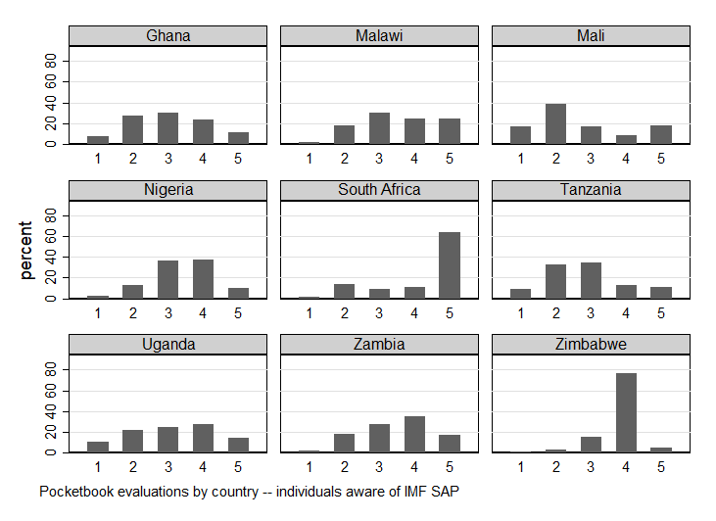
Notes: The graph shows the distribution of pocketbook evaluations of IMF SAPs in all Sub-Saharan African countries with available data and among SAP-aware individuals. Response categories are labelled as follows: 1=made it much worse, 2=made it worse, 3=neither worse nor better, 4=made it better, 5=made it much better

Figure A3.2: Perception of government biasedness across Asian countries
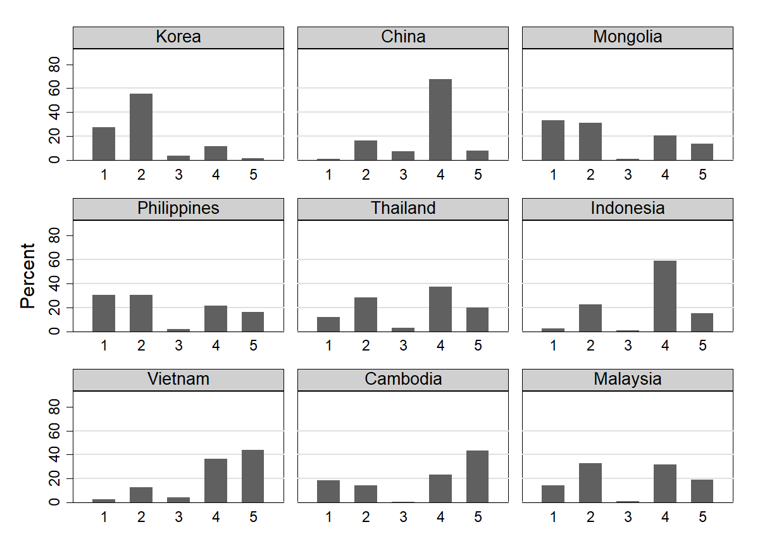
Notes: The graph shows the distribution of responses to the question: Does the government treat everyone equally? Answer categories are labelled: 1=strongly disagree, 2=disagree, 3=neither agree nor disagree, 4=agree, 5=strongly agree

Figure A3.3: Distribution of impressions of the IMF across Asian program countries
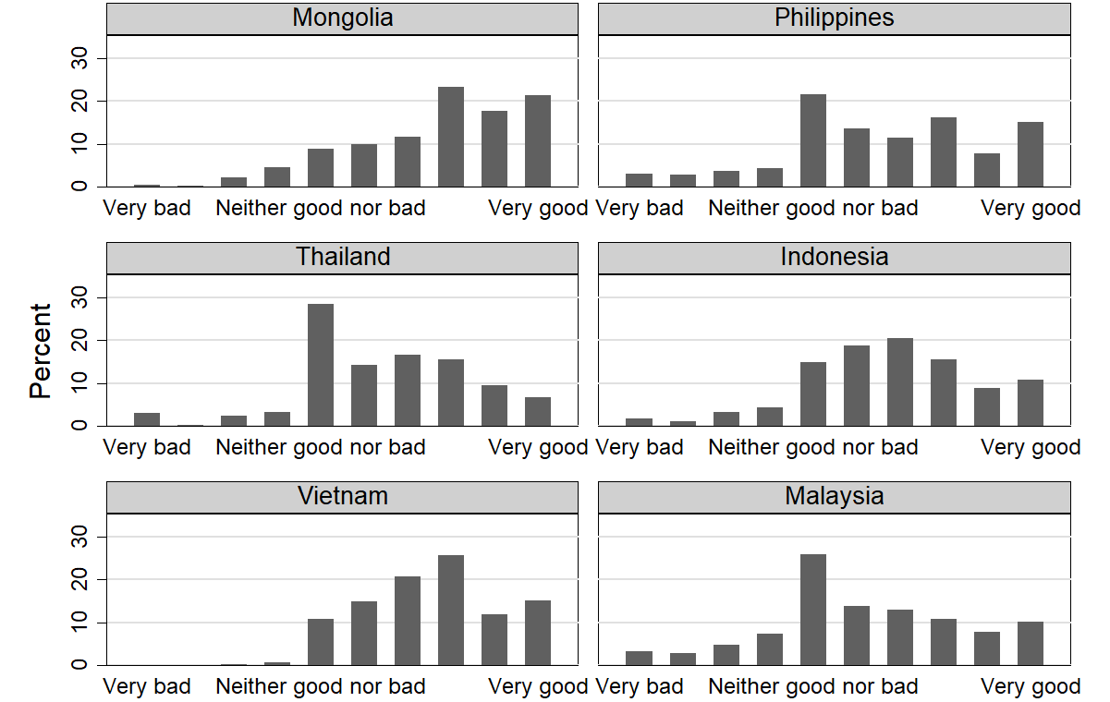
Notes: Graphs show the distribution of opinions about the Fund. Answer categories range from 1 (‘very bad’) to 10 (‘very good’).

Figure A3.4: Satisfaction with the quality of public education in Latin American program countries
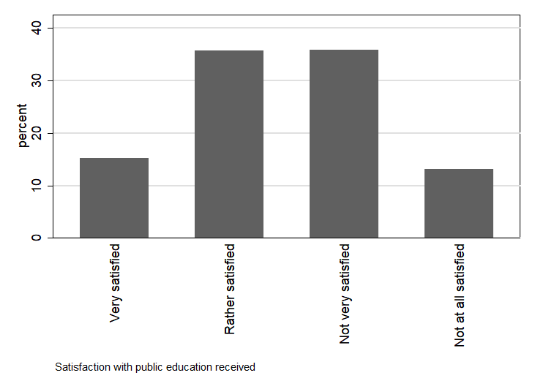

Figure A3.5: Perception of public education quality in Latin American program countries
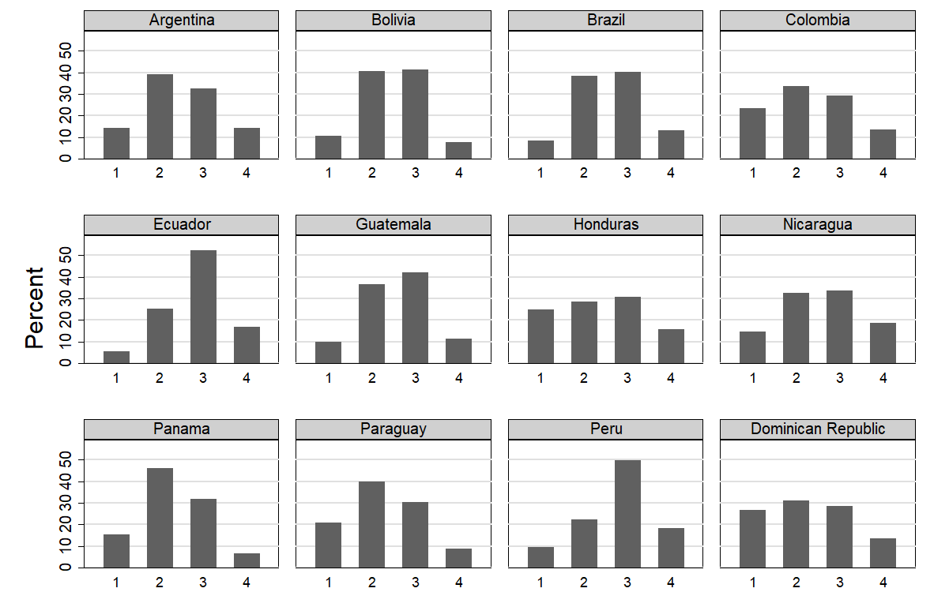
Notes: The graph shows the distribution of perceptions of the quality of public schools. Answers are labelled: 1=very satisfied, 2=satisfied, 3=dissatisfied, 4=very dissatisfied.

Figure A3.6: Satisfaction with the quality of health services in Latin American program countries

Figure A3.7: Perception of public health quality in Latin American program countries
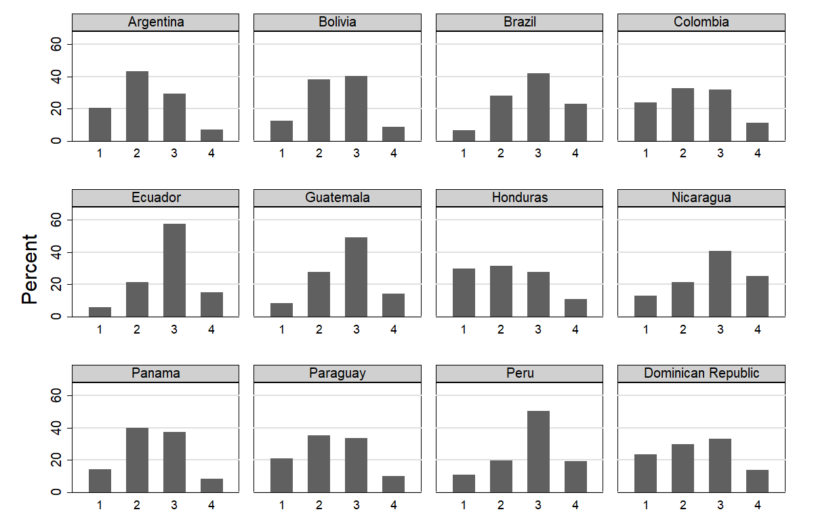
Notes: The graph shows the distribution of perceptions of the quality of public hospitals. Answers are labelled: 1=very satisfied, 2=satisfied, 3=dissatisfied, 4=very dissatisfied.
Figure A3.8: Protest across Afrobarometer countries
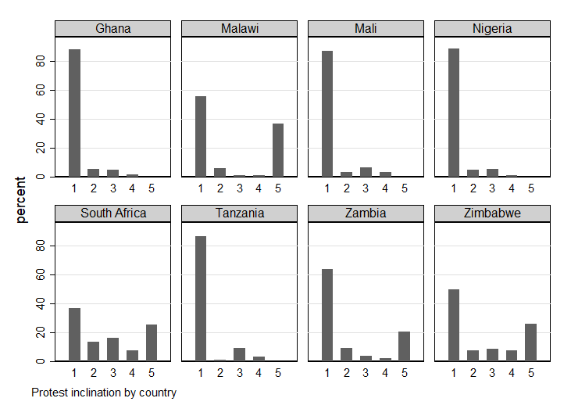
Notes: The graph shows the response distribution on the protest-related question among SAP-aware individuals. Response categories are labelled as follows: 1=never, 2=once, 3=a few times, 4=often, 5=would do if I could.

Figure A3.9: Protest in Asian Barometer program countries
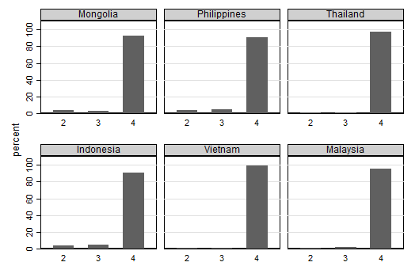
Notes: Protest behaviors across Asian program countries. Answer categories are labelled as: 2=Yes, once, 3=Yes, more than once, 4=No, would never do.

Figure A3.10: Protest across Latin American program countries
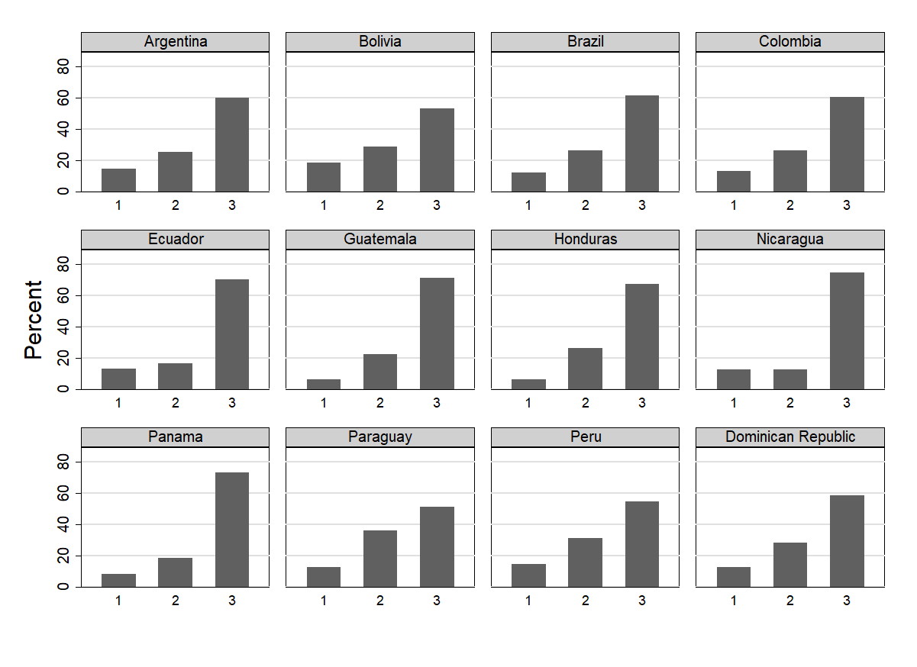

Notes: Distribution of protest preferences across countries. Answer categories are labelled as: 1=Have done, 2=Could do, 3=Never done.

Chapter 4
Table A4.1: Partisan allegiances, public sector employment, and pocketbook evaluations in African program countries
 | Public sector |  |  |  |  |  |  |  |  |  | Other sector
 | (1) |  |  | (2) |  |  |  | (3) |  |  |  | (4) |  |  | (5) |  |  |  | (6)
Opposition supporter | 0.389*** | (0.043) |  | 0.381*** |  | (0.040) |  | 0.364*** |  | (0.032) |  | 0.255*** | (0.066) |  | 0.239*** |  | (0.061) |  | 0.182*** |  | (0.044)
Male |  |  |  | 0.038 |  | (0.050) |  | 0.036 |  | (0.057) |  | -0.014 | (0.023) |  | -0.007 |  | (0.023) |  | -0.012 |  | (0.021)
(Logged) age |  |  |  | 0.047 |  | (0.133) |  | -0.002 |  | (0.146) |  | 0.098* | (0.041) |  | 0.097** |  | (0.035) |  | 0.090** |  | (0.033)
Urban |  |  |  | -0.111** |  | (0.033) |  | -0.110** |  | (0.038) |  | -0.031 | (0.020) |  | -0.024 |  | (0.023) |  | -0.022 |  | (0.023)
Unemployed |  |  |  | 0.000 |  | (.) |  | 0.000 |  | (.) |  | 0.061 | (0.063) |  | 0.051 |  | (0.062) |  | 0.047 |  | (0.058)
Educated |  |  |  | 0.033 |  | (0.054) |  | 0.012 |  | (0.046) |  | -0.024 | (0.030) |  | -0.018 |  | (0.029) |  | -0.021 |  | (0.029)
Radio listener |  |  |  | -0.155 |  | (0.081) |  | -0.139 |  | (0.092) |  | -0.003 | (0.023) |  | -0.010 |  | (0.022) |  | -0.016 |  | (0.023)
Politically interested |  |  |  | -0.053 |  | (0.038) |  | -0.043 |  | (0.036) |  | -0.049** | (0.017) |  | -0.049** |  | (0.017) |  | -0.045** |  | (0.017)
Politically knowledgeable |  |  |  | 0.165*** |  | (0.035) |  | 0.178*** |  | (0.027) |  | 0.055 | (0.029) |  | 0.069** |  | (0.024) |  | 0.071** |  | (0.023)
Satisfied with democracy |  |  |  | -0.049 |  | (0.067) |  | -0.031 |  | (0.055) |  |  |  |  | -0.040* |  | (0.017) |  | -0.020 |  | (0.018)
Prefers free market |  |  |  | -0.047 |  | (0.065) |  | -0.037 |  | (0.060) |  |  |  |  | -0.021 |  | (0.020) |  | -0.025 |  | (0.020)
Supports capitalism |  |  |  | 0.149*** |  | (0.027) |  | 0.138*** |  | (0.028) |  |  |  |  | 0.019 |  | (0.020) |  | 0.021 |  | (0.020)
Supports public sector |  |  |  | 0.089 |  | (0.059) |  | 0.100 |  | (0.059) |  |  |  |  | -0.017 |  | (0.020) |  | -0.017 |  | (0.021)
Supports privatization |  |  |  | 0.050 |  | (0.092) |  | 0.035 |  | (0.091) |  |  |  |  | 0.111 |  | (0.057) |  | 0.107 |  | (0.056)
Worse now than 12 months ago |  |  |  |  |  |  |  | 0.157** |  | (0.047) |  |  |  |  |  |  |  |  | 0.052** |  | (0.018)
Worse in 12 months |  |  |  |  |  |  |  | 0.057* |  | (0.026) |  |  |  |  |  |  |  |  | 0.049 |  | (0.026)
Dissatisfied with president |  |  |  |  |  |  |  | 0.128 |  | (0.145) |  |  |  |  |  |  |  |  | 0.167*** |  | (0.036)
Observations | 249 |  |  | 248 |  |  |  | 248 |  |  |  | 2678 |  |  | 2678 |  |  |  | 2678
Adjusted R2 | 0.169 |  |  | 0.208 |  |  |  | 0.225 |  |  |  | 0.221 |  |  | 0.232 |  |  |  | 0.249
Notes: Dependent variable is SAP made my life worse. Sample includes only respondents who are aware of the IMF SAP and only countries with an ongoing IMF program. Linear probability model with survey weights, country-fixed effects, and country-clustered standard errors. Significance levels: * p<.1 ** p<.05 *** p<.01

Table A4.2: Partisan allegiances, recent IMF program exposure, and deprivation in African program countries
 | (1) |  | (2) |  | (3)
Opposition supporter | -0.824*** | (0.181) | -0.696*** | (0.158) | -0.834*** | (0.166)
IMF program | 1.637*** | (0.083) | 1.667*** | (0.143) | 1.353*** | (0.143)
(Interaction) | 0.832*** | (0.239) | 0.824*** | (0.170) | 0.855*** | (0.172)
Male |  |  | 0.103** | (0.042) | 0.098* | (0.043)
(Logged) age |  |  | 0.387 | (0.218) | 0.377 | (0.219)
Urban |  |  | -0.572* | (0.273) | -0.560* | (0.268)
Unemployed |  |  | 0.137** | (0.049) | 0.092 | (0.051)
Educated |  |  | -0.176 | (0.148) | -0.173 | (0.144)
Radio listener |  |  | 0.136 | (0.108) | 0.141 | (0.110)
Politically interested |  |  | -0.193*** | (0.039) | -0.187*** | (0.038)
Politically knowledgeable |  |  | -0.358*** | (0.048) | -0.357*** | (0.047)
Satisfied with democracy |  |  | 0.043 | (0.129) | 0.081 | (0.112)
Prefers free market |  |  | -0.114** | (0.047) | -0.113* | (0.054)
Supports capitalism |  |  | -0.303** | (0.129) | -0.287* | (0.126)
Supports public sector |  |  | 0.107 | (0.151) | 0.104 | (0.146)
Supports privatization |  |  | 0.377*** | (0.057) | 0.382*** | (0.055)
Worse now than 12 months ago |  |  |  |  | 0.161** | (0.052)
Worse in 12 months |  |  |  |  | 0.158*** | (0.046)
Dissatisfied with president |  |  |  |  | 0.229** | (0.077)
Observations | 7879 |  | 7705 |  | 7705
Adjusted R2 | 0.067 |  | 0.120 |  | 0.125
Notes: Dependent variable is an index of deprivation, with higher values indicating more objective deprivation. Linear probability model with survey weights, country-fixed effects, and country-clustered standard errors. Significance levels: * p<.1 ** p<.05 *** p<.01

Table A4.3: Partisan allegiances, IMF conditionality, and deprivation in African program countries
 | (1) |  | (2) |  | (3)
Opposition supporter | -0.999** | (0.351) | -0.290 | (0.159) | -0.339 | (0.162)
Conditionality | 0.592*** | (0.022) | 0.610** | (0.142) | 0.419* | (0.182)
(Interaction) | 0.037 | (0.017) | 0.016* | (0.007) | 0.014 | (0.007)
Male |  |  | 0.094 | (0.070) | 0.089 | (0.070)
(Logged) age |  |  | 0.657*** | (0.104) | 0.648*** | (0.104)
Urban |  |  | -0.317 | (0.211) | -0.308 | (0.204)
Unemployed |  |  | 0.210*** | (0.021) | 0.164*** | (0.023)
Educated |  |  | -0.359*** | (0.062) | -0.351*** | (0.063)
Radio listener |  |  | 0.184 | (0.140) | 0.192 | (0.138)
Politically interested |  |  | -0.181*** | (0.028) | -0.174*** | (0.030)
Politically knowledgeable |  |  | -0.323** | (0.081) | -0.321** | (0.081)
Satisfied with democracy |  |  | 0.100 | (0.161) | 0.132 | (0.134)
Prefers free market |  |  | -0.119 | (0.072) | -0.124 | (0.079)
Supports capitalism |  |  | -0.224 | (0.170) | -0.214 | (0.169)
Supports public sector |  |  | 0.086 | (0.234) | 0.071 | (0.230)
Supports privatization |  |  | 0.381** | (0.083) | 0.379*** | (0.080)
Worse now than 12 months ago |  |  |  |  | 0.208*** | (0.028)
Worse in 12 months |  |  |  |  | 0.124* | (0.054)
Dissatisfied with president |  |  |  |  | 0.203 | (0.145)
Observations | 4775 |  | 4646 |  | 4646
Adjusted R2 | 0.017 |  | 0.066 |  | 0.069
Notes: Dependent variable is an index of deprivation, higher values indicating more objective deprivation. Linear probability model with survey weights, country-fixed effects, and country-clustered standard errors. Significance levels: * p<.1 ** p<.05 *** p<.01

Table A4.4: Partisan allegiances and pocketbook evaluations of IMF SAPs in Sub-Saharan Africa with selection model
 | (1) |  | (2) |  | (3)
Heard about IMF SAP
Politically interested | 0.093*** | (0.018) | 0.068*** | (0.018) | 0.067*** | (0.018)
Politically knowledgeable | 0.222*** | (0.040) | 0.140*** | (0.027) | 0.138*** | (0.026)
Opposition supporter | 0.027 | (0.017) | 0.011 | (0.020) | 0.012 | (0.020)
Male |  |  | 0.077*** | (0.019) | 0.077*** | (0.019)
(Logged) age |  |  | 0.084*** | (0.021) | 0.084*** | (0.020)
Urban |  |  | 0.035 | (0.022) | 0.033 | (0.022)
Employed |  |  | -0.046*** | (0.001) | -0.046*** | (0.002)
Educated |  |  | 0.181*** | (0.048) | 0.177*** | (0.049)
Supports democracy |  |  | 0.043** | (0.019) | 0.040** | (0.019)
Satisfied with democracy |  |  |  |  | 0.007 | (0.009)
Prefers free market |  |  |  |  | 0.021 | (0.021)
Supports capitalism |  |  |  |  | 0.027** | (0.013)
Supports public sector |  |  |  |  | 0.011 | (0.021)
Supports privatization |  |  |  |  | -0.029*** | (0.010)
Worse now than 12 months ago |  |  |  |  | -0.010 | (0.012)
Worse in 12 months |  |  |  |  | 0.002 | (0.011)
Dissatisfied with president |  |  |  |  | 0.001 | (0.020)
SAP made my life worse
Opposition supporter | 0.194*** | (0.066) | 0.200*** | (0.061) | 0.144*** | (0.044)
Male |  |  | -0.009 | (0.020) | -0.014 | (0.020)
(Logged) age |  |  | 0.080* | (0.044) | 0.063 | (0.041)
Urban |  |  | -0.039** | (0.019) | -0.032 | (0.020)
Employed |  |  | -0.057*** | (0.005) | -0.061*** | (0.004)
Educated |  |  | -0.034 | (0.053) | -0.043 | (0.055)
Supports democracy |  |  | -0.050 | (0.033) | -0.032 | (0.028)
Satisfied with democracy |  |  |  |  | -0.007 | (0.018)
Prefers free market |  |  |  |  | -0.017 | (0.027)
Supports capitalism |  |  |  |  | 0.027* | (0.014)
Supports public sector |  |  |  |  | 0.010 | (0.019)
Supports privatization |  |  |  |  | 0.107** | (0.048)
Worse now than 12 months ago |  |  |  |  | 0.061*** | (0.017)
Worse in 12 months |  |  |  |  | 0.060** | (0.029)
Dissatisfied with president |  |  |  |  | 0.159*** | (0.040)
Observation (equation 1) | 11192 |  | 10960 |  | 10960
Adjusted R2 (equation 1) | 0.262 |  | 0.303 |  | 0.305
Joint F-statistic (equation 1) | 48.010 |  | 36.496 |  | 38.075
Observations (equation 2) | 3679 |  | 3631 |  | 3631
Adjusted R2 (equation 2) | 0.166 |  | 0.232 |  | 0.259
Notes: System of two equations estimated via maximum likelihood. Dependent variables are heard of IMF SAP in the selection equation and SAP made my life worse in the outcome equation, defined only for those who heard about the IMF SAP. Linear probability model with survey weights, country-fixed effects, and country-clustered standard errors. Significance levels: * p<.1 ** p<.05 *** p<.01

Table A4.5: Partisan allegiances, IMF conditionality, and pocketbook evaluations of IMF SAPs in Sub-Saharan Africa with selection model
 | (1) |  | (2) |  | (3)
Heard about IMF SAP
Politically interested | 0.093*** | (0.018) | 0.068*** | (0.018) | 0.067*** | (0.018)
Politically knowledgeable | 0.222*** | (0.040) | 0.140*** | (0.027) | 0.138*** | (0.026)
Conditionality | 0.013*** | (0.000) | 0.008*** | (0.000) | 0.008*** | (0.000)
Opposition supporter | 0.027 | (0.017) | 0.011 | (0.020) | 0.012 | (0.020)
Male |  |  | 0.077*** | (0.019) | 0.077*** | (0.019)
(Logged) age |  |  | 0.084*** | (0.021) | 0.084*** | (0.020)
Urban |  |  | 0.035 | (0.022) | 0.033 | (0.022)
Employed |  |  | -0.046*** | (0.001) | -0.046*** | (0.002)
Educated |  |  | 0.181*** | (0.048) | 0.177*** | (0.049)
Supports democracy |  |  | 0.043** | (0.019) | 0.040** | (0.019)
Satisfied with democracy |  |  |  |  | 0.007 | (0.009)
Prefers free market |  |  |  |  | 0.021 | (0.021)
Supports capitalism |  |  |  |  | 0.027** | (0.013)
Supports public sector |  |  |  |  | 0.011 | (0.021)
Supports privatization |  |  |  |  | -0.029*** | (0.010)
Worse now than 12 months ago |  |  |  |  | -0.010 | (0.012)
Worse in 12 months |  |  |  |  | 0.002 | (0.011)
Dissatisfied with president |  |  |  |  | 0.001 | (0.020)
SAP made my life worse
Opposition supporter | 0.050 | (0.052) | 0.051 | (0.048) | 0.020 | (0.042)
Conditionality | 0.008*** | (0.001) | -0.002* | (0.001) | -0.002** | (0.001)
(Interaction) | 0.005*** | (0.001) | 0.006*** | (0.001) | 0.005*** | (0.001)
Male |  |  | -0.010 | (0.019) | -0.014 | (0.019)
(Logged) age |  |  | 0.081* | (0.043) | 0.063 | (0.040)
Urban |  |  | -0.041** | (0.019) | -0.034* | (0.020)
Employed |  |  | -0.057*** | (0.004) | -0.062*** | (0.004)
Educated |  |  | -0.033 | (0.051) | -0.043 | (0.053)
Supports democracy |  |  | -0.049 | (0.032) | -0.031 | (0.028)
Satisfied with democracy |  |  |  |  | -0.006 | (0.018)
Prefers free market |  |  |  |  | -0.014 | (0.028)
Supports capitalism |  |  |  |  | 0.026* | (0.014)
Supports public sector |  |  |  |  | 0.006 | (0.019)
Supports privatization |  |  |  |  | 0.104** | (0.048)
Worse now than 12 months ago |  |  |  |  | 0.059*** | (0.016)
Worse in 12 months |  |  |  |  | 0.061** | (0.030)
Dissatisfied with president |  |  |  |  | 0.154*** | (0.036)
Observation (equation 1) | 11192 |  | 10960 |  | 10960
Adjusted R2 (equation 1) | 0.262 |  | 0.303 |  | 0.305
Joint F-statistic (equation 1) | 47.988 |  | 36.533 |  | 38.102
Observations (equation 2) | 3679 |  | 3631 |  | 3631
Adjusted R2 (equation 2) | 0.230 |  | 0.238 |  | 0.264
Notes: System of two equations estimated via maximum likelihood. Dependent variables are heard of IMF SAP in the selection equation and SAP made my life worse in the outcome equation, defined only for those who heard about the IMF SAP. Linear probability model with survey weights, country-fixed effects, and country-clustered standard errors. Significance levels: * p<.1 ** p<.05 *** p<.01

Table A4.6: Ethnic allegiances and pocketbook evaluations of IMF SAPs in Sub-Saharan Africa
 | (1) |  | (2) |  | (3)
Ethnic minority | 0.209* | (0.117) | 0.216* | (0.100) | 0.147** | (0.029)
Male |  |  | 0.077* | (0.026) | 0.070 | (0.025)
(Logged) age |  |  | 0.114* | (0.037) | 0.110* | (0.027)
Urban |  |  | -0.007 | (0.013) | -0.014 | (0.016)
Employed |  |  | 0.113** | (0.013) | 0.107** | (0.015)
Educated |  |  | -0.059 | (0.033) | -0.062 | (0.030)
Supports democracy |  |  | 0.031 | (0.022) | 0.029 | (0.023)
Politically interested |  |  | -0.066* | (0.020) | -0.056* | (0.013)
Politically knowledgeable |  |  | 0.047 | (0.017) | 0.046* | (0.014)
Satisfied with democracy |  |  | -0.008 | (0.031) | 0.018 | (0.009)
Prefers free market |  |  | -0.009 | (0.013) | -0.009 | (0.011)
Supports capitalism |  |  | 0.080** | (0.015) | 0.078** | (0.018)
Supports public sector |  |  | 0.029 | (0.013) | 0.016** | (0.003)
Supports privatization |  |  | -0.010 | (0.065) | -0.015 | (0.056)
Worse now than 12 months ago |  |  |  |  | 0.056** | (0.011)
Worse in 12 months |  |  |  |  | -0.015 | (0.019)
Dissatisfied with president |  |  |  |  | 0.386*** | (0.021)
Observations | 1655 |  | 1641 |  | 1641
Adjusted R2 | 0.055 |  | 0.078 |  | 0.108
Notes: Dependent variable is SAP made my life worse. Linear probability model with survey weights, country-fixed effects, and country-clustered standard errors. Significance levels: * p<.1 ** p<.05 *** p<.01

Table A4.7: Ethnic allegiances and pocketbook evaluations of IMF SAPs in Sub-Saharan Africa
 | (1) |  | (2) |  | (3)
Ethnic minority | 0.105*** | (0.000) | 0.116*** | (0.010) | 0.114*** | (0.008)
IMF program | -0.256*** | (0.009) | -0.263*** | (0.011) | -0.372*** | (0.011)
(Interaction) | 0.275** | (0.036) | 0.268** | (0.030) | 0.095*** | (0.008)
Male |  |  | 0.077* | (0.026) | 0.070 | (0.025)
(Logged) age |  |  | 0.111* | (0.035) | 0.108* | (0.026)
Urban |  |  | -0.001 | (0.016) | -0.011 | (0.016)
Employed |  |  | 0.117*** | (0.010) | 0.108** | (0.013)
Educated |  |  | -0.058 | (0.032) | -0.061 | (0.030)
Supports democracy |  |  | 0.034 | (0.020) | 0.030 | (0.022)
Politically interested |  |  | -0.068* | (0.020) | -0.057* | (0.014)
Politically knowledgeable |  |  | 0.046 | (0.016) | 0.046* | (0.014)
Satisfied with democracy |  |  | -0.007 | (0.031) | 0.017 | (0.009)
Prefers free market |  |  | -0.010 | (0.014) | -0.010 | (0.011)
Supports capitalism |  |  | 0.081** | (0.015) | 0.078** | (0.018)
Supports public sector |  |  | 0.028 | (0.013) | 0.016** | (0.003)
Supports privatization |  |  | -0.012 | (0.063) | -0.015 | (0.055)
Worse now than 12 months ago |  |  |  |  | 0.057** | (0.011)
Worse in 12 months |  |  |  |  | -0.014 | (0.018)
Dissatisfied with president |  |  |  |  | 0.368*** | (0.010)
Observations | 1655 |  | 1641 |  | 1641
Adjusted R2 | 0.060 |  | 0.083 |  | 0.108
Notes: Dependent variable is SAP made my life worse. Linear probability model with survey weights, country-fixed effects, and country-clustered standard errors. Significance levels: * p<.1 ** p<.05 *** p<.01

Table A4.8: Partisan allegiances and pocketbook evaluations of IMF SAPs in Sub-Saharan Africa using survey-adjusted probit models
 | (1) |  | (2) |  | (3)
Opposition supporter | 0.447** | (0.198) | 0.444** | (0.177) | 0.341** | (0.138)
Male |  |  | 0.103 | (0.063) | 0.093 | (0.064)
(Logged) age |  |  | 0.243*** | (0.083) | 0.221*** | (0.083)
Urban |  |  | -0.127** | (0.054) | -0.135** | (0.059)
Employed |  |  | -0.416*** | (0.009) | -0.275*** | (0.024)
Educated |  |  | -0.002 | (0.080) | -0.007 | (0.081)
Supports democracy |  |  | -0.090 | (0.100) | -0.060 | (0.086)
Politically interested |  |  | -0.131*** | (0.033) | -0.111*** | (0.031)
Politically knowledgeable |  |  | 0.279*** | (0.035) | 0.292*** | (0.038)
Satisfied with democracy |  |  | -0.022 | (0.084) | 0.014 | (0.076)
Prefers free market |  |  | 0.026 | (0.081) | 0.032 | (0.090)
Supports capitalism |  |  | 0.107*** | (0.027) | 0.108*** | (0.030)
Supports public sector |  |  | 0.059* | (0.035) | 0.044 | (0.038)
Supports privatization |  |  | 0.267** | (0.114) | 0.267** | (0.112)
Worse now than 12 months ago |  |  |  |  | 0.181*** | (0.038)
Worse in 12 months |  |  |  |  | 0.228** | (0.104)
Dissatisfied with president |  |  |  |  | 0.529*** | (0.170)
Observations | 3679 |  | 3631 |  | 3631
Pseudo R2 | 0.148 |  | 0.168 |  | 0.182
Notes: Dependent variable is SAP made my life worse. Sample includes only individuals who are aware of the IMF program. Probit model with survey weights and country-clustered standard errors. Significance levels: * p<.1 ** p<.05 *** p<.01

Table A4.9: Partisan allegiances, IMF programs, and pocketbook evaluations of IMF SAPs in Sub-Saharan Africa using survey-adjusted probit models
 | (1) |  | (2) |  | (3)
Opposition supporter | 0.063 | (0.050) | 0.084** | (0.042) | 0.058 | (0.068)
IMF program | 0.652*** | (0.068) | -0.702*** | (0.104) | -0.074 | (0.153)
(Interaction) | 0.713*** | (0.149) | 0.674*** | (0.122) | 0.570*** | (0.114)
Male |  |  | 0.102 | (0.063) | 0.093 | (0.064)
(Logged) age |  |  | 0.245*** | (0.080) | 0.224*** | (0.082)
Urban |  |  | -0.133** | (0.056) | -0.140** | (0.061)
Employed |  |  | -0.439*** | (0.017) | -0.310*** | (0.024)
Educated |  |  | -0.010 | (0.080) | -0.012 | (0.081)
Supports democracy |  |  | -0.084 | (0.092) | -0.059 | (0.083)
Politically interested |  |  | -0.114*** | (0.036) | -0.098*** | (0.032)
Politically knowledgeable |  |  | 0.266*** | (0.035) | 0.282*** | (0.038)
Satisfied with democracy |  |  | -0.001 | (0.087) | 0.025 | (0.076)
Prefers free market |  |  | 0.053 | (0.084) | 0.055 | (0.090)
Supports capitalism |  |  | 0.101*** | (0.029) | 0.103*** | (0.030)
Supports public sector |  |  | 0.033 | (0.035) | 0.023 | (0.039)
Supports privatization |  |  | 0.255** | (0.111) | 0.256** | (0.109)
Worse now than 12 months ago |  |  |  |  | 0.181*** | (0.038)
Worse in 12 months |  |  |  |  | 0.236** | (0.108)
Dissatisfied with president |  |  |  |  | 0.425*** | (0.143)
Observations | 3679 |  | 3631 |  | 3631
Pseudo R2 | 0.158 |  | 0.177 |  | 0.188
Notes: Dependent variable is SAP made my life worse. Sample includes only individuals who are aware of the IMF program. Probit model with survey weights and country-clustered standard errors. Significance levels: * p<.1 ** p<.05 *** p<.01

Table A4.10: Partisan allegiances, IMF conditionality, and pocketbook evaluations of IMF SAPs in Sub-Saharan Africa using survey-adjusted probit models
 | (1) |  | (2) |  | (3)
Opposition supporter | 0.128** | (0.063) | 0.147** | (0.065) | 0.099* | (0.060)
Conditionality | -0.141*** | (0.006) | -0.046*** | (0.005) | -0.039*** | (0.004)
(Interaction) | 0.018*** | (0.004) | 0.017*** | (0.004) | 0.014*** | (0.003)
Male |  |  | 0.103 | (0.063) | 0.093 | (0.065)
(Logged) age |  |  | 0.243*** | (0.082) | 0.222*** | (0.083)
Urban |  |  | -0.136** | (0.055) | -0.142** | (0.060)
Employed |  |  | -0.317*** | (0.031) | -0.201*** | (0.029)
Educated |  |  | -0.006 | (0.080) | -0.009 | (0.081)
Supports democracy |  |  | -0.085 | (0.096) | -0.058 | (0.085)
Politically interested |  |  | -0.116*** | (0.037) | -0.099*** | (0.033)
Politically knowledgeable |  |  | 0.267*** | (0.035) | 0.282*** | (0.038)
Satisfied with democracy |  |  | -0.009 | (0.090) | 0.022 | (0.077)
Prefers free market |  |  | 0.047 | (0.086) | 0.050 | (0.092)
Supports capitalism |  |  | 0.102*** | (0.028) | 0.104*** | (0.029)
Supports public sector |  |  | 0.040 | (0.035) | 0.028 | (0.039)
Supports privatization |  |  | 0.255** | (0.112) | 0.256** | (0.110)
Worse now than 12 months ago |  |  |  |  | 0.179*** | (0.038)
Worse in 12 months |  |  |  |  | 0.233** | (0.107)
Dissatisfied with president |  |  |  |  | 0.466*** | (0.146)
Observations | 3679 |  | 3631 |  | 3631
Pseudo R2 | 0.156 |  | 0.175 |  | 0.187
Notes: Dependent variable is SAP made my life worse. Sample includes only individuals who are aware of the IMF program. Probit model with survey weights and country-clustered standard errors. Significance levels: * p<.1 ** p<.05 *** p<.01

Table A4.11: Partisan allegiances and pocketbook evaluations of IMF SAPs in Sub-Saharan Africa using multi-level models
 | (1) |  | (2) |  | (3)
Opposition supporter | 0.446** | (0.198) | 0.444** | (0.177) | 0.340** | (0.137)
Male |  |  | 0.101 | (0.064) | 0.090 | (0.065)
(Logged) age |  |  | 0.242*** | (0.082) | 0.217*** | (0.082)
Urban |  |  | -0.128** | (0.052) | -0.136** | (0.056)
Employed |  |  | -0.202*** | (0.052) | -0.210*** | (0.036)
Educated |  |  | 0.000 | (0.080) | -0.003 | (0.079)
Supports democracy |  |  | -0.091 | (0.099) | -0.060 | (0.085)
Politically interested |  |  | -0.134*** | (0.034) | -0.113*** | (0.031)
Politically knowledgeable |  |  | 0.279*** | (0.035) | 0.291*** | (0.037)
Satisfied with democracy |  |  | -0.027 | (0.086) | 0.011 | (0.078)
Prefers free market |  |  | 0.023 | (0.082) | 0.028 | (0.091)
Supports capitalism |  |  | 0.104*** | (0.027) | 0.105*** | (0.030)
Supports public sector |  |  | 0.062* | (0.035) | 0.051 | (0.038)
Supports privatization |  |  | 0.266** | (0.114) | 0.267** | (0.112)
Worse now than 12 months ago |  |  |  |  | 0.184*** | (0.040)
Worse in 12 months |  |  |  |  | 0.242** | (0.108)
Dissatisfied with president |  |  |  |  | 0.542*** | (0.169)
Observations | 3679 |  | 3631 |  | 3631
Pseudo R2 | 0.148 |  | 0.168 |  | 0.182
Notes: Dependent variable is SAP made my life worse. Sample includes only individuals who are aware of the IMF program. Multi-level random-intercept model with survey weights and country-clustered standard errors. Significance levels: * p<.1 ** p<.05 *** p<.01

Table A4.12: Partisan allegiances, IMF programs, and pocketbook evaluations of IMF SAPs in Sub-Saharan Africa using multi-level models.
 | (1) |  | (2) |  | (3)
Opposition supporter | 0.063 | (0.050) | 0.085** | (0.043) | 0.058 | (0.069)
IMF program | 0.122 | (0.645) | 0.116 | (0.224) | 0.048 | (0.165)
(Interaction) | 0.710*** | (0.149) | 0.672*** | (0.122) | 0.565*** | (0.115)
Male |  |  | 0.100 | (0.064) | 0.090 | (0.066)
(Logged) age |  |  | 0.244*** | (0.079) | 0.220*** | (0.080)
Urban |  |  | -0.131** | (0.056) | -0.137** | (0.061)
Employed |  |  | -0.209*** | (0.046) | -0.215*** | (0.035)
Educated |  |  | -0.006 | (0.080) | -0.005 | (0.082)
Supports democracy |  |  | -0.084 | (0.091) | -0.058 | (0.081)
Politically interested |  |  | -0.117*** | (0.036) | -0.101*** | (0.032)
Politically knowledgeable |  |  | 0.267*** | (0.034) | 0.282*** | (0.037)
Satisfied with democracy |  |  | -0.006 | (0.089) | 0.021 | (0.077)
Prefers free market |  |  | 0.049 | (0.085) | 0.050 | (0.092)
Supports capitalism |  |  | 0.097*** | (0.028) | 0.099*** | (0.030)
Supports public sector |  |  | 0.036 | (0.034) | 0.030 | (0.038)
Supports privatization |  |  | 0.254** | (0.111) | 0.256** | (0.108)
Worse now than 12 months ago |  |  |  |  | 0.184*** | (0.040)
Worse in 12 months |  |  |  |  | 0.251** | (0.112)
Dissatisfied with president |  |  |  |  | 0.441*** | (0.142)
Observations | 3679 |  | 3631 |  | 3631
Adjusted R2 | 0.158 |  | 0.177 |  | 0.188
Notes: Dependent variable is SAP made my life worse. Sample includes only individuals who are aware of the IMF program. Multi-level random-intercept model with survey weights and country-clustered standard errors. Significance levels: * p<.1 ** p<.05 *** p<.01

Table A4.13: Partisan allegiances, IMF conditionality, and pocketbook evaluations of IMF SAPs in Sub-Saharan Africa using multi-level models
 | (1) |  | (2) |  | (3)
Opposition supporter | 0.128** | (0.062) | 0.147** | (0.066) | 0.098 | (0.062)
Conditionality | 0.005 | (0.015) | 0.005* | (0.003) | 0.004* | (0.002)
(Interaction) | 0.018*** | (0.004) | 0.017*** | (0.004) | 0.014*** | (0.003)
Male |  |  | 0.100 | (0.064) | 0.090 | (0.067)
(Logged) age |  |  | 0.242*** | (0.081) | 0.219*** | (0.081)
Urban |  |  | -0.134** | (0.054) | -0.138** | (0.059)
Employed |  |  | -0.206*** | (0.044) | -0.214*** | (0.032)
Educated |  |  | -0.002 | (0.080) | -0.003 | (0.082)
Supports democracy |  |  | -0.085 | (0.095) | -0.056 | (0.083)
Politically interested |  |  | -0.120*** | (0.037) | -0.102*** | (0.034)
Politically knowledgeable |  |  | 0.268*** | (0.034) | 0.283*** | (0.037)
Satisfied with democracy |  |  | -0.013 | (0.092) | 0.018 | (0.079)
Prefers free market |  |  | 0.043 | (0.087) | 0.044 | (0.094)
Supports capitalism |  |  | 0.098*** | (0.028) | 0.099*** | (0.029)
Supports public sector |  |  | 0.043 | (0.034) | 0.035 | (0.038)
Supports privatization |  |  | 0.254** | (0.112) | 0.256** | (0.109)
Worse now than 12 months ago |  |  |  |  | 0.182*** | (0.040)
Worse in 12 months |  |  |  |  | 0.250** | (0.112)
Dissatisfied with president |  |  |  |  | 0.486*** | (0.143)
Observations | 3679 |  | 3631 |  | 3631
Pseudo R2 | 0.158 |  | 0.177 |  | 0.188
Notes: Dependent variable is SAP made my life worse. Sample includes only individuals who are aware of the IMF program. Multi-level random-intercept model with survey weights and country-clustered standard errors. Significance levels: * p<.1 ** p<.05 *** p<.01

Asian Barometer
Table A4.14: Partisan allegiances, IMF conditionality, and perception of government biasedness in Asian program countries considering sample selection
 | (1) |  | (2) |  | (3)
Heard about the IMF
Politically interested | 0.097*** | (0.022) | 0.078*** | (0.022) | 0.075*** | (0.022)
Politically informed | 0.149*** | (0.019) | 0.131*** | (0.019) | 0.130*** | (0.019)
Average conditionality | 0.054*** | (0.005) | 0.038*** | (0.005) | 0.034*** | (0.006)
Opposition supporter | 0.019 | (0.021) | -0.014 | (0.020) | -0.015 | (0.020)
Male |  |  | 0.098*** | (0.019) | 0.095*** | (0.019)
(Logged) age |  |  | -0.022 | (0.014) | -0.021 | (0.014)
Urban |  |  | -0.107*** | (0.019) | -0.104*** | (0.019)
Employed |  |  | -0.011 | (0.019) | -0.012 | (0.019)
Education |  |  | -0.115*** | (0.015) | -0.114*** | (0.015)
Supports democracy |  |  | 0.080*** | (0.020) | 0.078*** | (0.020)
Democracy over growth |  |  | -0.016 | (0.025) | -0.018 | (0.025)
Economy got worse |  |  |  |  | -0.008 | (0.022)
Must obey government |  |  |  |  | -0.043** | (0.020)
Supports majority rule |  |  |  |  | 0.044** | (0.020)
Government is biased
Average conditionality | 0.060*** | (0.014) | 0.059*** | (0.013) | 0.065*** | (0.013)
Opposition supporter | -0.270* | (0.146) | -0.298** | (0.147) | -0.282* | (0.146)
(Interaction) | 0.029** | (0.012) | 0.031** | (0.012) | 0.029** | (0.012)
Male |  |  | -0.039 | (0.033) | -0.040 | (0.033)
(Logged) age |  |  | -0.013 | (0.019) | -0.009 | (0.019)
Urban |  |  | -0.075** | (0.033) | -0.063* | (0.033)
Employed |  |  | 0.042 | (0.027) | 0.041 | (0.027)
Education |  |  | 0.022 | (0.030) | 0.029 | (0.030)
Supports democracy |  |  | -0.013 | (0.030) | -0.015 | (0.030)
Democracy over growth |  |  | -0.022 | (0.032) | -0.022 | (0.032)
Economy got worse |  |  |  |  | 0.072** | (0.030)
Must obey government |  |  |  |  | -0.071** | (0.029)
Supports majority rule |  |  |  |  | -0.049* | (0.029)
Observations (equation 1) | 2322 |  | 2320 |  | 2320
Adjusted R2 (equation 1) | 0.128 |  | 0.191 |  | 0.193
Joint F-statistic (equation 1) | 104.390 |  | 73.130 |  | 70.707
Observations (equation 2) | 1592 |  | 1591 |  | 1591
Adjusted R2 (equation 2) | 0.146 |  | 0.154 |  | 0.162
Notes: System of two equations estimated via maximum likelihood. Dependent variables are heard of IMF in the selection equation and government is biased in the outcome equation, defined only for those who heard about the IMF. Linear probability model with survey weights, country-fixed effects, and country-clustered standard errors. Significance levels: * p<.1 ** p<.05 *** p<.01

Table A4.15: Partisan allegiances, IMF program exposure, and bad impression of the IMF
 | (1) |  | (2) |  | (3)
IMF exposure | -0.265*** | (0.075) | -0.238*** | (0.076) | -0.226*** | (0.076)
Opposition supporter | 0.002 | (0.023) | 0.001 | (0.024) | 0.002 | (0.024)
(Interaction) | -0.010 | (0.032) | -0.007 | (0.033) | -0.008 | (0.033)
Male | 0.008 | (0.013) | 0.015 | (0.014) | 0.017 | (0.015)
(Logged) age |  |  | -0.005 | (0.013) | -0.005 | (0.013)
Urban |  |  | 0.024*** | (0.009) | 0.024*** | (0.009)
Employed |  |  | -0.013 | (0.013) | -0.014 | (0.013)
Education |  |  | -0.000 | (0.014) | -0.000 | (0.014)
Supports democracy |  |  | 0.016* | (0.010) | 0.016* | (0.010)
Democracy over growth |  |  | -0.001 | (0.014) | -0.001 | (0.014)
Economy got worse |  |  | 0.014 | (0.017) | 0.014 | (0.017)
Must obey government |  |  |  |  | -0.023 | (0.015)
Supports majority rule |  |  |  |  | 0.001 | (0.015)
Observations | 2578 |  | 2325 |  | 2325
Adjusted R2 | 0.014 |  | 0.017 |  | 0.016
Notes: Dependent variable is bad impression of the IMF. Sample includes only respondents who are aware of the IMF. Linear probability model with survey weights, country-fixed effects, and country-clustered standard errors. Significance levels: * p<.1 ** p<.05 *** p<.01

Table A4.16: Partisan allegiances, IMF conditionality, and bad impression of the IMF
 | (1) |  | (2) |  | (3)
Average conditionality | 0.002 | (0.005) | 0.005 | (0.005) | 0.006 | (0.006)
Opposition supporter | 0.195** | (0.086) | 0.185** | (0.088) | 0.182** | (0.088)
(Interaction) | -0.016** | (0.007) | -0.015** | (0.007) | -0.015** | (0.007)
Male | 0.026 | (0.016) | 0.026 | (0.016) | 0.023 | (0.016)
(Logged) age |  |  | -0.011 | (0.015) | -0.010 | (0.015)
Urban |  |  | 0.023** | (0.010) | 0.024** | (0.010)
Employed |  |  | -0.009 | (0.014) | -0.008 | (0.014)
Education |  |  | 0.020 | (0.015) | 0.020 | (0.015)
Supports democracy |  |  | 0.017 | (0.011) | 0.018 | (0.011)
Democracy over growth |  |  | 0.001 | (0.016) | -0.000 | (0.016)
Economy got worse |  |  | 0.006 | (0.019) | 0.006 | (0.019)
Must obey government |  |  |  |  | -0.006 | (0.019)
Supports majority rule |  |  |  |  | -0.022 | (0.017)
Observations | 1482 |  | 1481 |  | 1481
Adjusted R2 | 0.004 |  | 0.006 |  | 0.007
Notes: Dependent variable is bad impression of the IMF. Sample includes only respondents who are aware of the IMF. Linear probability model with survey weights, country-fixed effects, and country-clustered standard errors. Significance levels: * p<.1 ** p<.05 *** p<.01

World Values Survey
Table 4.17: Partisan allegiance, financial crisis, and income group by IMF exposure
 | Crisis resolution with IMF program |  |  |  |  |  |  |  |  | Crisis resolution without program
 | (1) |  |  | (2) |  |  | (3) |  |  | (4) |  | (5) |  |  | (6)
Financial crisis | -0.064 | (0.101) |  | -0.154 | (0.152) |  | -0.199 |  | (0.154) | 0.108 | (0.076) | 0.116 |  | (0.095) | 0.084 |  | (0.092)
Opposition supporter | 0.035*** | (0.011) |  | 0.004 | (0.010) |  | 0.006 |  | (0.010) | -0.004 | (0.011) | -0.002 |  | (0.010) | -0.002 |  | (0.010)
(Interaction) | -0.088*** | (0.033) |  | -0.071** | (0.030) |  | -0.071*** |  | (0.026) | -0.022 | (0.063) | -0.030 |  | (0.065) | -0.037 |  | (0.059)
Male |  |  |  | -0.007 | (0.008) |  | -0.007 |  | (0.009) |  |  | -0.009 |  | (0.007) | -0.007 |  | (0.007)
(Logged) age |  |  |  | -0.053* | (0.029) |  | -0.043 |  | (0.030) |  |  | -0.066** |  | (0.029) | -0.080*** |  | (0.027)
Married |  |  |  | 0.079*** | (0.012) |  | 0.076*** |  | (0.012) |  |  | 0.147*** |  | (0.023) | 0.147*** |  | (0.024)
Household size |  |  |  | -0.019*** | (0.004) |  | -0.022*** |  | (0.004) |  |  | -0.017*** |  | (0.003) | -0.016*** |  | (0.003)
Underemployed |  |  |  | -0.112*** | (0.015) |  | -0.108*** |  | (0.015) |  |  | -0.150*** |  | (0.020) | -0.147*** |  | (0.021)
Educated |  |  |  | 0.273*** | (0.015) |  | 0.265*** |  | (0.014) |  |  | 0.278*** |  | (0.021) | 0.255*** |  | (0.019)
Politically interested |  |  |  | 0.057*** | (0.008) |  | 0.048*** |  | (0.009) |  |  | 0.063*** |  | (0.009) | 0.058*** |  | (0.010)
Demand for democracy |  |  |  |  |  |  | 0.015 |  | (0.013) |  |  |  |  |  | 0.015 |  | (0.019)
Priority for growth |  |  |  |  |  |  | -0.008 |  | (0.007) |  |  |  |  |  | -0.030*** |  | (0.010)
Preference for equality |  |  |  |  |  |  | -0.071*** |  | (0.009) |  |  |  |  |  | -0.121*** |  | (0.012)
Confidence in government |  |  |  |  |  |  | -0.004 |  | (0.009) |  |  |  |  |  | 0.010 |  | (0.016)
Observations | 137168 |  |  | 115814 |  |  | 93483 |  |  | 200950 |  | 177801 |  |  | 133818
Countries | 58 |  |  | 55 |  |  | 55 |  |  | 64 |  | 62 |  |  | 58
Adjusted R2 | 0.121 |  |  | 0.194 |  |  | 0.194 |  |  | 0.072 |  | 0.138 |  |  | 0.130
Notes: Dependent variable is the income group. Financial crisis is measured as the share of years with a financial crisis over the three-year period before the survey. Linear probability model with survey weights, country-fixed effects, year-fixed effects, and country-clustered standard errors in parentheses. Significance levels: * p<.1 ** p<.05 *** p<.01.

Table 4.18: Partisan allegiance, financial crisis, and deprivation by IMF exposure
 | Crisis resolution with IMF program |  |  |  |  |  |  |  |  | Crisis resolution without program
 | (1) |  |  | (2) |  |  | (3) |  |  | (4) |  | (5) |  |  | (6)
Financial crisis | -- | -- |  | -- | -- |  | -- |  | -- | -0.607 | (0.373) | -0.805** |  | (0.378) | -0.727** |  | (0.356)
Opposition supporter | -0.052 | (0.053) |  | 0.015 | (0.044) |  | -0.000 |  | (0.047) | 0.049 | (0.035) | 0.039 |  | (0.035) | 0.012 |  | (0.034)
(Interaction) | 0.319*** | (0.053) |  | 0.181*** | (0.044) |  | 0.198*** |  | (0.047) | 0.044 | (0.266) | 0.023 |  | (0.253) | 0.057 |  | (0.252)
Male |  |  |  | -0.098** | (0.043) |  | -0.115** |  | (0.048) |  |  | 0.030 |  | (0.027) | 0.025 |  | (0.028)
(Logged) age |  |  |  | 0.107 | (0.128) |  | 0.098 |  | (0.132) |  |  | -0.327*** |  | (0.104) | -0.322*** |  | (0.103)
Married |  |  |  | -0.235*** | (0.055) |  | -0.222*** |  | (0.060) |  |  | -0.260*** |  | (0.043) | -0.251*** |  | (0.046)
Household size |  |  |  | 0.106*** | (0.023) |  | 0.105*** |  | (0.026) |  |  | 0.105*** |  | (0.018) | 0.105*** |  | (0.019)
Underemployed |  |  |  | 0.343*** | (0.069) |  | 0.340*** |  | (0.068) |  |  | 0.234*** |  | (0.037) | 0.238*** |  | (0.041)
Educated |  |  |  | -0.613*** | (0.093) |  | -0.567*** |  | (0.101) |  |  | -0.553*** |  | (0.070) | -0.535*** |  | (0.074)
Politically interested |  |  |  | 0.035 | (0.038) |  | 0.068* |  | (0.037) |  |  | 0.054 |  | (0.050) | 0.070 |  | (0.049)
Demand for democracy |  |  |  |  |  |  | -0.227** |  | (0.078) |  |  |  |  |  | -0.244*** |  | (0.076)
Priority for growth |  |  |  |  |  |  | 0.112** |  | (0.053) |  |  |  |  |  | 0.052* |  | (0.028)
Preference for equality |  |  |  |  |  |  | 0.160* |  | (0.077) |  |  |  |  |  | 0.152*** |  | (0.044)
Confidence in government |  |  |  |  |  |  | -0.110 |  | (0.085) |  |  |  |  |  | -0.070 |  | (0.059)
Observations | 31105 |  |  | 30539 |  |  | 26590 |  |  | 99757 |  | 95134 |  |  | 81716
Countries | 19 |  |  | 19 |  |  | 18 |  |  | 46 |  | 46 |  |  | 44
Adjusted R2 | 0.141 |  |  | 0.167 |  |  | 0.175 |  |  | 0.207 |  | 0.231 |  |  | 0.243
Notes: Dependent variable is the deprivation index. Both ‘financial crisis’ and ‘IMF program’ are measured two years before the survey. Linear probability model with survey weights, country-fixed effects, year-fixed effects, and country-clustered standard errors in parentheses. Significance levels: * p<.1 ** p<.05 *** p<.01.

Table 4.19: Partisan allegiance, financial crisis, and income group by IMF exposure
 | Crisis resolution with IMF program |  |  |  |  |  |  |  |  | Crisis resolution without program
 | (1) |  |  | (2) |  |  | (3) |  |  | (4) |  | (5) |  |  | (6)
Financial crisis | 0.066 | (0.123) |  | -0.613*** | (0.012) |  | -0.706*** |  | (0.013) | 0.009 | (0.047) | 0.025 |  | (0.059) | 0.018 |  | (0.061)
Opposition supporter | 0.036*** | (0.013) |  | 0.011 | (0.012) |  | 0.013 |  | (0.012) | 0.000 | (0.010) | -0.002 |  | (0.009) | 0.000 |  | (0.009)
(Interaction) | -0.089*** | (0.029) |  | -0.072*** | (0.023) |  | -0.077*** |  | (0.023) | -0.076* | (0.041) | -0.076** |  | (0.036) | -0.079** |  | (0.035)
Male |  |  |  | -0.004 | (0.009) |  | -0.006 |  | (0.010) |  |  | -0.009 |  | (0.007) | -0.007 |  | (0.007)
(Logged) age |  |  |  | -0.081*** | (0.030) |  | -0.071** |  | (0.030) |  |  | -0.056** |  | (0.027) | -0.067** |  | (0.026)
Married |  |  |  | 0.078*** | (0.013) |  | 0.074*** |  | (0.013) |  |  | 0.140*** |  | (0.021) | 0.138*** |  | (0.022)
Household size |  |  |  | -0.017*** | (0.004) |  | -0.021*** |  | (0.004) |  |  | -0.017*** |  | (0.003) | -0.016*** |  | (0.003)
Underemployed |  |  |  | -0.118*** | (0.019) |  | -0.114*** |  | (0.018) |  |  | -0.141*** |  | (0.018) | -0.137*** |  | (0.019)
Educated |  |  |  | 0.273*** | (0.019) |  | 0.270*** |  | (0.018) |  |  | 0.278*** |  | (0.019) | 0.253*** |  | (0.018)
Politically interested |  |  |  | 0.048*** | (0.007) |  | 0.041*** |  | (0.008) |  |  | 0.060*** |  | (0.008) | 0.055*** |  | (0.009)
Demand for democracy |  |  |  |  |  |  | 0.014 |  | (0.016) |  |  |  |  |  | 0.015 |  | (0.018)
Priority for growth |  |  |  |  |  |  | -0.013* |  | (0.007) |  |  |  |  |  | -0.025*** |  | (0.009)
Preference for equality |  |  |  |  |  |  | -0.067*** |  | (0.010) |  |  |  |  |  | -0.120*** |  | (0.013)
Confidence in government |  |  |  |  |  |  | -0.009 |  | (0.010) |  |  |  |  |  | 0.006 |  | (0.014)
Observations | 105980 |  |  | 88982 |  |  | 70232 |  |  | 232138 |  | 204633 |  |  | 157069
Countries | 51 |  |  | 49 |  |  | 46 |  |  | 71 |  | 68 |  |  | 65
Adjusted R2 | 0.131 |  |  | 0.212 |  |  | 0.208 |  |  | 0.073 |  | 0.137 |  |  | 0.130
Notes: Dependent variable is the income group. Both ‘financial crisis’ and ‘IMF program’ are measured two years before the survey. Linear probability model with survey weights, country-fixed effects, year-fixed effects, and country-clustered standard errors in parentheses. Significance levels: * p<.1 ** p<.05 *** p<.01.

Figure A4.1: Partisan allegiance, financial crisis, and income group by IMF program
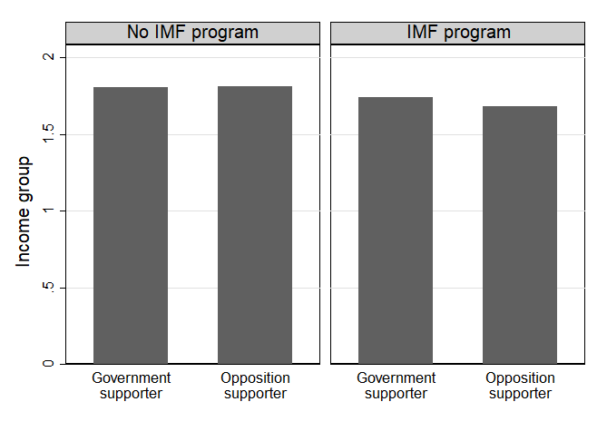
Chapter 5
Table A5.1: Deprivation, IMF conditionality, and protest
 | (1) |  | (2) |  | (3)
Deprivation index | -0.011** | (0.003) | -0.009** | (0.002) | -0.009** | (0.002)
Conditionality | 0.010*** | (0.001) | 0.010*** | (0.000) | 0.009*** | (0.001)
(Interaction) | 0.000** | (0.000) | 0.001** | (0.000) | 0.001** | (0.000)
Male |  |  | 0.021 | (0.031) | 0.021 | (0.031)
(Logged) age |  |  | -0.025 | (0.043) | -0.024 | (0.043)
Urban |  |  | 0.068** | (0.017) | 0.067** | (0.016)
Unemployed |  |  | 0.025** | (0.008) | 0.024* | (0.009)
Educated |  |  | 0.016 | (0.014) | 0.015 | (0.014)
Radio listener |  |  | 0.007 | (0.010) | 0.007 | (0.010)
Politically interested |  |  | 0.067*** | (0.012) | 0.068*** | (0.011)
Politically knowledgeable |  |  | 0.021 | (0.021) | 0.019 | (0.020)
Satisfied with democracy |  |  | 0.000 | (0.013) | 0.005 | (0.017)
Prefers free market |  |  | 0.022 | (0.018) | 0.022 | (0.017)
Supports capitalism |  |  | 0.020 | (0.012) | 0.020 | (0.011)
Supports public sector |  |  | -0.005 | (0.010) | -0.004 | (0.010)
Supports privatization |  |  | 0.010* | (0.004) | 0.011* | (0.004)
Worse now than 12 months ago |  |  |  |  | -0.000 | (0.011)
Worse in 12 months |  |  |  |  | -0.010 | (0.016)
Dissatisfied with president |  |  |  |  | 0.028 | (0.029)
Observations | 6910 |  | 6675 |  | 6675
Adjusted R2 | 0.049 |  | 0.072 |  | 0.073
Notes: Dependent variable is protest. Sample includes only countries with a recent IMF program. Linear probability model with survey weights and country-clustered standard errors. Significance levels: * p<.1 ** p<.05 *** p<.01

Table A5.2: Partisan allegiances and protest in Sub-Saharan Africa taking sample selection into account
 | (1) |  | (2) |  | (3)
Heard about the IMF SAP
Politically interested | 0.097*** | (0.018) | 0.074*** | (0.017) | 0.075*** | (0.017)
Politically knowledgeable | 0.220*** | (0.040) | 0.135*** | (0.027) | 0.132*** | (0.026)
Opposition supporter | 0.027 | (0.017) | 0.011 | (0.020) | 0.013 | (0.020)
Male |  |  | 0.077*** | (0.019) | 0.077*** | (0.019)
(Logged) age |  |  | 0.084*** | (0.021) | 0.084*** | (0.020)
Urban |  |  | 0.035 | (0.022) | 0.033 | (0.022)
Employed |  |  | -0.046*** | (0.001) | -0.046*** | (0.002)
Educated |  |  | 0.182*** | (0.049) | 0.178*** | (0.049)
Supports democracy |  |  | 0.043** | (0.019) | 0.040** | (0.019)
Satisfied with democracy |  |  |  |  | 0.007 | (0.009)
Prefers free market |  |  |  |  | 0.021 | (0.021)
Supports capitalism |  |  |  |  | 0.027** | (0.013)
Supports public sector |  |  |  |  | 0.010 | (0.021)
Supports privatization |  |  |  |  | -0.029*** | (0.010)
Worse now than 12 months ago |  |  |  |  | -0.010 | (0.012)
Worse in 12 months |  |  |  |  | 0.002 | (0.011)
Dissatisfied with president |  |  |  |  | 0.001 | (0.019)
Protest
Opposition supporter | 0.078** | (0.037) | 0.062* | (0.034) | 0.057* | (0.034)
Male |  |  | -0.009 | (0.021) | -0.010 | (0.021)
(Logged) age |  |  | -0.116*** | (0.037) | -0.115*** | (0.037)
Urban |  |  | 0.075*** | (0.018) | 0.076*** | (0.019)
Employed |  |  | 0.062*** | (0.002) | 0.063*** | (0.003)
Educated |  |  | -0.001 | (0.024) | -0.001 | (0.026)
Supports democracy |  |  | -0.052* | (0.030) | -0.048 | (0.031)
Satisfied with democracy |  |  |  |  | 0.001 | (0.019)
Prefers free market |  |  |  |  | -0.016 | (0.019)
Supports capitalism |  |  |  |  | -0.024 | (0.016)
Supports public sector |  |  |  |  | 0.015 | (0.016)
Supports privatization |  |  |  |  | 0.025* | (0.013)
Worse now than 12 months ago |  |  |  |  | -0.005 | (0.014)
Worse in 12 months |  |  |  |  | -0.023 | (0.020)
Dissatisfied with president |  |  |  |  | 0.032* | (0.018)
Observations (equation 1) | 11192 |  | 10960 |  | 10960
Adjusted R2 (equation 1) | 0.262 |  | 0.303 |  | 0.305
Joint F-statistic (equation 1) | 49.972 |  | 37.143 |  | 38.980
Observations (equation 2) | 2996 |  | 2966 |  | 2966
Adjusted R2 (equation 2) | 0.087 |  | 0.123 |  | 0.125
Notes: System of two equations estimated via maximum likelihood. Dependent variables are heard of IMF SAP in the selection equation and protest in the outcome equation, defined only for those who heard about the IMF SAP. Linear probability model with survey weights and country-clustered standard errors. Significance levels: * p<.1 ** p<.05 *** p<.01

Table A5.3: Ethnic allegiances, IMF program exposure, and protest in Africa
 | IMF program |  |  |  |  |  | No IMF program
 | (1) |  | (2) |  | (3) |  | (4) |  | (5) |  | (6)
Ethnic minority | 0.034** | (0.013) | 0.086*** | (0.016) | 0.078*** | (0.017) | -0.002 | (0.024) | -0.003 | (0.024) | -0.002 | (0.025)
Male |  |  | 0.003 | (0.015) | 0.002 | (0.015) |  |  | 0.036*** | (0.011) | 0.036*** | (0.011)
(Logged) age |  |  | 0.032 | (0.022) | 0.034 | (0.022) |  |  | -0.040*** | (0.014) | -0.039*** | (0.014)
Urban |  |  | 0.045*** | (0.017) | 0.045*** | (0.017) |  |  | 0.013 | (0.011) | 0.013 | (0.011)
Unemployed |  |  | 0.014*** | (0.004) | 0.012*** | (0.004) |  |  | 0.015*** | (0.002) | 0.014*** | (0.002)
Educated |  |  | 0.050*** | (0.017) | 0.052*** | (0.017) |  |  | 0.051*** | (0.012) | 0.051*** | (0.012)
Radio listener |  |  | 0.019 | (0.016) | 0.023 | (0.017) |  |  | 0.001 | (0.013) | 0.002 | (0.013)
Politically interested |  |  | 0.042** | (0.018) | 0.042** | (0.018) |  |  | 0.071*** | (0.015) | 0.071*** | (0.015)
Politically knowledgeable |  |  | 0.001 | (0.019) | 0.000 | (0.019) |  |  | 0.047** | (0.020) | 0.047** | (0.020)
Satisfied with democracy |  |  | -0.026* | (0.015) | -0.022 | (0.016) |  |  | 0.006 | (0.011) | 0.006 | (0.011)
Supports free market |  |  | 0.028* | (0.015) | 0.027* | (0.015) |  |  | 0.021* | (0.011) | 0.021* | (0.011)
Supports capitalism |  |  | 0.023 | (0.016) | 0.024 | (0.016) |  |  | 0.024** | (0.011) | 0.024** | (0.011)
Supports public sector |  |  | -0.001 | (0.016) | -0.004 | (0.016) |  |  | 0.006 | (0.012) | 0.007 | (0.012)
Supports privatization |  |  | 0.006 | (0.015) | 0.005 | (0.015) |  |  | -0.011 | (0.012) | -0.011 | (0.012)
Worse now than 12 months ago |  |  |  |  | 0.024 | (0.016) |  |  |  |  | -0.004 | (0.014)
Worse in 12 months |  |  |  |  | -0.001 | (0.017) |  |  |  |  | 0.024 | (0.033)
Dissatisfied with president |  |  |  |  | 0.012 | (0.019) |  |  |  |  | 0.024 | (0.031)
Observations | 2323 |  | 2300 |  | 2300 |  | 673 |  | 673 |  | 673
Adjusted R2 | 0.049 |  | 0.076 |  | 0.078 |  | 0.11 |  | 0.152 |  | 0.159
Notes: Dependent variable is protest. Linear probability models with survey weights and robust standard errors (due to low number of clusters). Significance levels: * p<.1 ** p<.05 *** p<.01

Table A5.4: Ethnic allegiances, partisan allegiances, and protest in African program countries
 | (1) |  | (2) |  | (3)
Ethnic minority | -0.138*** | (0.001) | -0.153* | (0.023) | -0.148* | (0.021)
Opposition supporter | 0.094 | (0.030) | 0.073** | (0.003) | 0.045 | (0.012)
(Interaction) | 0.227** | (0.004) | 0.246* | (0.022) | 0.232* | (0.025)
Male |  |  | 0.048 | (0.026) | 0.047 | (0.026)
(Logged) age |  |  | 0.057 | (0.049) | 0.060 | (0.046)
Urban |  |  | -0.032 | (0.037) | -0.030 | (0.036)
Unemployed |  |  | -0.043 | (0.029) | -0.052 | (0.031)
Educated |  |  | 0.067 | (0.066) | 0.067 | (0.066)
Radio listener |  |  | -0.022 | (0.024) | -0.021 | (0.024)
Politically interested |  |  | -0.005 | (0.026) | -0.004 | (0.025)
Politically knowledgeable |  |  | 0.094* | (0.014) | 0.095* | (0.012)
Satisfied with democracy |  |  | 0.010 | (0.007) | 0.019 | (0.011)
Supports free market |  |  | 0.033 | (0.006) | 0.031 | (0.006)
Supports capitalism |  |  | 0.029 | (0.048) | 0.031 | (0.050)
Supports public sector |  |  | 0.035 | (0.065) | 0.031 | (0.066)
Supports privatization |  |  | 0.016 | (0.084) | 0.016 | (0.082)
Worse now than 12 months ago |  |  |  |  | 0.017* | (0.002)
Worse in 12 months |  |  |  |  | 0.010 | (0.016)
Dissatisfied with president |  |  |  |  | 0.059 | (0.032)
Observations | 1747 |  | 1685 |  | 1685
Adjusted R2 | 0.120 |  | 0.158 |  | 0.160
Notes: Dependent variables is protest. Sample includes only countries under IMF programs. Linear probability model with survey weights and country-clustered standard errors. Significance levels: * p<.1 ** p<.05 *** p<.01

Table A5.5: Pocketbook IMF SAP evaluations and protest inclinations in Sub-Saharan Africa
 | (1) |  | (2) |  | (3)
SAP made my life worse | 0.066*** | (0.012) | 0.046** | (0.013) | 0.046*** | (0.013)
Male |  |  | 0.032*** | (0.009) | 0.033*** | (0.009)
(Logged) age |  |  | -0.089** | (0.032) | -0.089** | (0.032)
Urban |  |  | 0.012 | (0.020) | 0.012 | (0.020)
Unemployed |  |  | 0.047** | (0.017) | 0.047** | (0.017)
Educated |  |  | -0.020** | (0.008) | -0.020** | (0.007)
Radio listener |  |  | -0.007** | (0.003) | -0.007** | (0.003)
Politically interested |  |  | 0.062*** | (0.010) | 0.062*** | (0.009)
Politically knowledgeable |  |  | 0.047*** | (0.012) | 0.047*** | (0.012)
Satisfied with democracy |  |  | 0.013 | (0.013) | 0.012 | (0.010)
Supports free market |  |  | 0.013* | (0.007) | 0.013 | (0.007)
Supports capitalism |  |  | 0.001 | (0.011) | 0.001 | (0.012)
Supports public sector |  |  | 0.013 | (0.013) | 0.013 | (0.013)
Supports privatization |  |  | 0.016 | (0.017) | 0.016 | (0.016)
Worse now than 12 months ago |  |  |  |  | -0.002 | (0.005)
Worse in 12 months |  |  |  |  | -0.009 | (0.013)
Dissatisfied with president |  |  |  |  | 0.001 | (0.042)
Observations | 15609 |  | 15338 |  | 15338
Adjusted R2 | 0.226 |  | 0.244 |  | 0.244
Notes: Dependent variables is protest. Linear probability model with survey weights and country-clustered standard errors. Significance levels: * p<.1 ** p<.05 *** p<.01

Table A5.6: Pocketbook IMF SAP evaluations and protest using simple probit models.
 | (1) |  | (2) |  | (3)
SAP made my life worse | 0.355*** | (0.052) | 0.244*** | (0.052) | 0.252*** | (0.052)
Male |  |  | 0.211*** | (0.066) | 0.211*** | (0.066)
(Logged) age |  |  | -0.425*** | (0.116) | -0.421*** | (0.114)
Urban |  |  | 0.162* | (0.085) | 0.164* | (0.085)
Unemployed |  |  | 0.283*** | (0.081) | 0.289*** | (0.080)
Educated |  |  | -0.101** | (0.045) | -0.101** | (0.044)
Radio listener |  |  | -0.038 | (0.024) | -0.038 | (0.024)
Politically interested |  |  | 0.365*** | (0.022) | 0.362*** | (0.022)
Politically knowledgeable |  |  | 0.204*** | (0.045) | 0.203*** | (0.044)
Satisfied with democracy |  |  | 0.085 | (0.056) | 0.073 | (0.049)
Supports free market |  |  | 0.078** | (0.038) | 0.076** | (0.038)
Supports capitalism |  |  | 0.035 | (0.032) | 0.034 | (0.033)
Supports public sector |  |  | 0.017 | (0.044) | 0.016 | (0.041)
Supports privatization |  |  | 0.061 | (0.068) | 0.059 | (0.065)
Worse now than 12 months ago |  |  |  |  | -0.049** | (0.020)
Worse in 12 months |  |  |  |  | -0.040 | (0.045)
Dissatisfied with president |  |  |  |  | -0.083 | (0.110)
Observations | 14092 |  | 13850 |  | 13850
Pseudo R2 | 0.101 |  | 0.140 |  | 0.141
Notes: Dependent variables is protest. Probit models with survey weights and country-clustered standard errors. Significance levels: * p<.1 ** p<.05 *** p<.01

Table A5.7: Pocketbook IMF SAP evaluations and protest using multi-level models
 | (1) |  | (2) |  | (3)
SAP made my life worse | 0.356*** | (0.050) | 0.245*** | (0.050) | 0.252*** | (0.050)
Male |  |  | 0.210*** | (0.066) | 0.211*** | (0.066)
(Logged) age |  |  | -0.423*** | (0.116) | -0.420*** | (0.114)
Urban |  |  | 0.162* | (0.084) | 0.165* | (0.084)
Unemployed |  |  | 0.281*** | (0.082) | 0.287*** | (0.081)
Educated |  |  | -0.100** | (0.045) | -0.100** | (0.045)
Radio listener |  |  | -0.039 | (0.024) | -0.039 | (0.024)
Politically interested |  |  | 0.364*** | (0.022) | 0.361*** | (0.022)
Politically knowledgeable |  |  | 0.205*** | (0.045) | 0.204*** | (0.044)
Satisfied with democracy |  |  | 0.083 | (0.056) | 0.072 | (0.049)
Supports free market |  |  | 0.077** | (0.038) | 0.076** | (0.038)
Supports capitalism |  |  | 0.034 | (0.032) | 0.034 | (0.033)
Supports public sector |  |  | 0.016 | (0.044) | 0.015 | (0.041)
Supports privatization |  |  | 0.061 | (0.068) | 0.058 | (0.065)
Worse now than 12 months ago |  |  |  |  | -0.048** | (0.019)
Worse in 12 months |  |  |  |  | -0.037 | (0.044)
Dissatisfied with president |  |  |  |  | -0.079 | (0.113)
Observations | 14092 |  | 13850 |  | 13850
Pseudo R2 | 0.101 |  | 0.140 |  | 0.141
Notes: Dependent variables is protest. Multi-level models with survey weights and country-clustered standard errors. Significance levels: * p<.1 ** p<.05 *** p<.01

Asian Barometer
Table A5.8: Partisan allegiances, IMF conditionality, and protest in Asian program countries.
 | (1) |  | (2) |  | (3)
Heard about the IMF
Politically interested | 0.024 | (0.025) | 0.032 | (0.027) | 0.032 | (0.027)
Politically informed | 0.087* | (0.047) | 0.067 | (0.043) | 0.066 | (0.042)
Opposition supporter | 0.017*** | (0.006) | 0.007 | (0.007) | 0.006 | (0.008)
Male |  |  | 0.045 | (0.034) | 0.044 | (0.033)
(Logged) age |  |  | -0.018 | (0.015) | -0.018 | (0.015)
Urban |  |  | -0.074 | (0.046) | -0.074 | (0.045)
Employed |  |  | 0.029 | (0.024) | 0.028 | (0.024)
Education |  |  | -0.053 | (0.034) | -0.052 | (0.033)
Supports democracy |  |  | 0.035 | (0.031) | 0.034 | (0.031)
Democracy over growth |  |  | 0.004 | (0.023) | 0.003 | (0.022)
Economy got worse |  |  |  |  | 0.004 | (0.018)
Must obey government |  |  |  |  | -0.024 | (0.017)
Supports majority rule |  |  |  |  | 0.031* | (0.018)
Protest
IMF exposure
Opposition supporter | 0.034** | (0.013) | 0.025* | (0.015) | 0.025 | (0.016)
(Interaction) | 0.047*** | (0.013) | 0.042*** | (0.012) | 0.042*** | (0.011)
Male |  |  | -0.008 | (0.005) | -0.008 | (0.006)
(Logged) age |  |  | -0.035** | (0.016) | -0.034** | (0.015)
Urban |  |  | 0.016 | (0.013) | 0.018 | (0.015)
Employed |  |  | -0.021 | (0.024) | -0.021 | (0.024)
Education |  |  | 0.018 | (0.017) | 0.018 | (0.018)
Supports democracy |  |  | -0.023*** | (0.007) | -0.023*** | (0.008)
Democracy over growth |  |  | 0.012 | (0.022) | 0.013 | (0.022)
Economy got worse |  |  |  |  | -0.006 | (0.021)
Must obey government |  |  |  |  | 0.009 | (0.012)
Supports majority rule |  |  |  |  | -0.023*** | (0.008)
Observations (equation 1) | 8489 |  | 7050 |  | 7050
Adjusted R2 (equation 1) | 3.441 |  | 2.554 |  | 2.542
Joint F-statistic (equation 1) | 0.501 |  | 0.550 |  | 0.550
Observations (equation 2) | 2813 |  | 2481 |  | 2481
Adjusted R2 (equation 2) | 0.017 |  | 0.026 |  | 0.025
Notes: System of two equations estimated via maximum likelihood. Dependent variables are heard of IMF in the selection equation and protest in the outcome equation, defined only for those who heard about the IMF. Linear probability model with survey weights, country-fixed effects, and country-clustered standard errors. Significance levels: * p<.1 ** p<.05 *** p<.01

Table A5.9: Partisan allegiances, IMF conditionality, and protest in Asian program countries
 | (1) |  | (2) |  | (3)
Heard about the IMF
Politically interested | 0.113*** | (0.011) | 0.095*** | (0.007) | 0.094*** | (0.006)
Politically informed | 0.136 | (0.084) | 0.116*** | (0.045) | 0.114*** | (0.040)
Average conditionality | 0.053*** | (0.004) | 0.038*** | (0.011) | 0.034*** | (0.012)
Opposition supporter | 0.018*** | (0.003) | -0.015 | (0.023) | -0.015 | (0.022)
Male |  |  | 0.097 | (0.068) | 0.094 | (0.067)
(Logged) age |  |  | -0.021 | (0.038) | -0.020 | (0.036)
Urban |  |  | -0.108 | (0.077) | -0.105 | (0.076)
Employed |  |  | -0.011 | (0.030) | -0.012 | (0.030)
Education |  |  | -0.115*** | (0.035) | -0.114*** | (0.033)
Supports democracy |  |  | 0.079 | (0.065) | 0.077 | (0.064)
Democracy over growth |  |  | -0.017 | (0.065) | -0.020 | (0.064)
Economy got worse |  |  |  |  | -0.006 | (0.019)
Must obey government |  |  |  |  | -0.044*** | (0.016)
Supports majority rule |  |  |  |  | 0.044 | (0.032)
Protest
Average conditionality | -0.021* | (0.011) | -0.027*** | (0.010) | -0.026*** | (0.010)
Opposition supporter | -0.109*** | (0.004) | -0.084*** | (0.009) | -0.079*** | (0.014)
(Interaction) | 0.014*** | (0.000) | 0.011*** | (0.000) | 0.011*** | (0.001)
Male |  |  | -0.008* | (0.005) | -0.009*** | (0.002)
(Logged) age |  |  | -0.056*** | (0.001) | -0.055*** | (0.000)
Urban |  |  | 0.006 | (0.028) | 0.008 | (0.031)
Employed |  |  | -0.011 | (0.012) | -0.011 | (0.012)
Education |  |  | 0.029 | (0.025) | 0.032 | (0.023)
Supports democracy |  |  | -0.028* | (0.015) | -0.030* | (0.017)
Democracy over growth |  |  | 0.039 | (0.031) | 0.040 | (0.032)
Economy got worse |  |  |  |  | 0.005 | (0.004)
Must obey government |  |  |  |  | -0.010 | (0.021)
Supports majority rule |  |  |  |  | -0.022*** | (0.004)
Observations (equation 1) | 2322 |  | 2320 |  | 2156
Adjusted R2 (equation 1) | 0.128 |  | 0.191 |  | 0.180
Joint F-statistic (equation 1) | 2.623 |  | 6.740 |  | 8.991
Observations (equation 2) | 1590 |  | 1589 |  | 1517
Adjusted R2 (equation 2) | 0.097 |  | 0.037 |  | 0.040
Notes: System of two equations estimated via maximum likelihood. Dependent variables are heard of IMF in the selection equation and protest in the outcome equation, defined only for those who heard about the IMF. Linear probability model with survey weights, country-fixed effects, and country-clustered standard errors. Significance levels: * p<.1 ** p<.05 *** p<.01

World Values Survey
Table A5.10: Partisan allegiance, financial crisis, and protest by IMF exposure
 | Crisis resolution with IMF program |  |  |  |  |  |  |  |  | Crisis resolution without program
 | (1) |  |  | (2) |  |  | (3) |  |  | (4) |  | (5) |  |  | (6)
Financial crisis | -- | -- |  | -- | -- |  | -- |  | -- | -0.118 | (0.106) | -0.290*** |  | (0.063) | -0.295*** |  | (0.055)
Opposition supporter | 0.014 | (0.014) |  | 0.007 | (0.012) |  | 0.007 |  | (0.013) | 0.015 | (0.016) | 0.009 |  | (0.017) | 0.004 |  | (0.016)
(Interaction) | 0.083** | (0.040) |  | 0.076 | (0.057) |  | 0.075 |  | (0.062) | 0.050 | (0.051) | 0.090 |  | (0.064) | 0.089 |  | (0.060)
Male |  |  |  | 0.028*** | (0.009) |  | 0.029*** |  | (0.010) |  |  | 0.022*** |  | (0.006) | 0.018*** |  | (0.006)
(Logged) age |  |  |  | -0.011 | (0.016) |  | -0.013 |  | (0.018) |  |  | -0.025 |  | (0.017) | -0.029 |  | (0.018)
Married |  |  |  | -0.020*** | (0.007) |  | -0.026** |  | (0.009) |  |  | -0.011 |  | (0.007) | -0.013* |  | (0.007)
Household size |  |  |  | 0.003 | (0.003) |  | 0.003 |  | (0.003) |  |  | -0.004* |  | (0.002) | -0.004 |  | (0.003)
Underemployed |  |  |  | -0.052*** | (0.007) |  | -0.053*** |  | (0.007) |  |  | -0.009* |  | (0.005) | -0.009 |  | (0.006)
Educated |  |  |  | 0.088*** | (0.019) |  | 0.083*** |  | (0.020) |  |  | 0.049*** |  | (0.012) | 0.047*** |  | (0.013)
Politically interested |  |  |  | 0.091*** | (0.013) |  | 0.090*** |  | (0.013) |  |  | 0.096*** |  | (0.009) | 0.102*** |  | (0.010)
Demand for democracy |  |  |  |  |  |  | 0.010 |  | (0.013) |  |  |  |  |  | 0.016 |  | (0.011)
Priority for growth |  |  |  |  |  |  | -0.036*** |  | (0.010) |  |  |  |  |  | -0.015* |  | (0.008)
Preference for equality |  |  |  |  |  |  | 0.003 |  | (0.013) |  |  |  |  |  | 0.019** |  | (0.008)
Confidence in government |  |  |  |  |  |  | -0.030** |  | (0.013) |  |  |  |  |  | -0.028*** |  | (0.010)
Observations | 105980 |  |  | 88982 |  |  | 70232 |  |  | 232138 |  | 204633 |  |  | 157069
Countries | 51 |  |  | 49 |  |  | 46 |  |  | 71 |  | 68 |  |  | 65
Adjusted R2 | 0.131 |  |  | 0.212 |  |  | 0.208 |  |  | 0.073 |  | 0.137 |  |  | 0.130
Notes: Dependent variable is protest. Both ‘financial crisis’ and ‘IMF program’ are measured two years before the survey. Linear probability model with survey weights, country-fixed effects, year-fixed effects, and country-clustered standard errors in parentheses. Significance levels: * p<.1 ** p<.05 *** p<.01.

Figure A5.1: Partisan allegiance and protest in Asian program countries
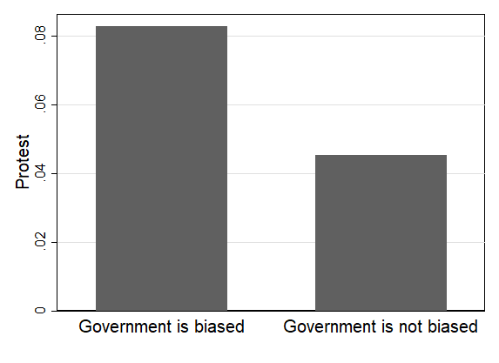
Figure A5.2: Partisan allegiance, IMF conditionality, and protest in Asian program countries
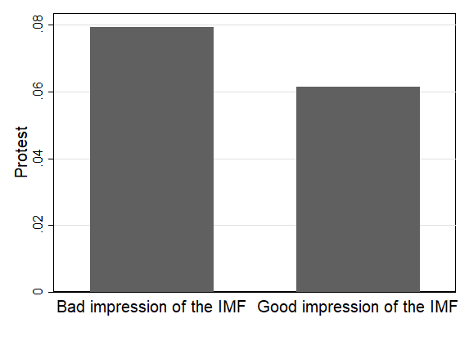
Figure A5.3: Government biasedness, program design, and protest in Asian program countries
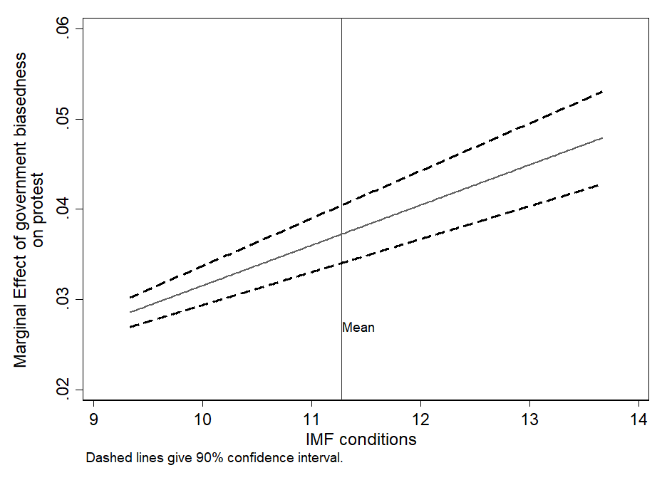

Figure A5.4: Partisan allegiances, program design, and protest in Asian program countries
