Instructions for Contributors to Wireless Power Transfer

First A. Author1, Second Author1,2, Third Author2

1 Cambridge University Press, Edinburgh Building, Shaftesbury Road, Cambridge, CB28RU, United Kingdom

2 CTTC, Av. Carl Friedrich Gauss 7, 08860 Castelldefels, Barcelona, Spain.

This file provides instructions for authors submitting papers to WPT, and is available in Microsoft Word and PDF formats as well as a LaTeX file. These instructions are also arranged in the style of a submitted paper, so either the Word or LaTeX file can also be used as a template for submissions. As all accepted papers will be imported into typesetting software by Cambridge University Press, there is no need for authors to spend unnecessary time formatting their paper to match the appearance of the final published article. However authors must follow rules expressly specified in this document (such as how references should be formatted). All papers must include an abstract, which should be a single paragraph not exceeding 200 words providing a short summary of the main aims, results and conclusions in such a way that it highlights the importance of the paper to the wider community, not only to experts in the subject.

Corresponding author: F. A. Author; email: author@email.com; phone: +44 1234 567 890

I. INTRODUCTION

Launched in 2014, Wireless Power Transfer is the first journal dedicated to publishing original research and industrial developments relating to wireless power. The Journal pulls together research from across the field, covering aspects such as RF technology, near-field energy transfer, energy conversion and management, electromagnetic harvesting, novel materials and fabrication techniques, energy storage elements, and RFID-related electronics. WPT covers all methods of wireless power transfer and articles will reflect the full diversity of applications for this technology, including mobile communications, medical implants, automotive technology, and spacecraft engineering.

The journal encourages the submission of two types of paper, described below. Note that all papers should begin with an ‘Introduction’ section and finish with ‘Conclusions’.

A) Research Papers

These papers describe new results in the field of wireless power transfer.

B) Review Papers

These papers provide overviews of the status of research and development on particular topics.

II. SUBMISSION
To submit a paper, go to the submission page at: http://mc.manuscriptcentral.com/wpt
You can then log in if you already have an account, or register a new account if you have not used the site before. Once logged in you will be able to click on the 'Author Center' link and follow the online instructions to proceed with your submission. Before submitting your paper, please make sure that you have read the remainder of these instructions.

A) Original Work

Submission of a manuscript implies that it has been approved in its final form by all the named authors, that it reports on unpublished work and that it has not been published or is being considered for publication, in whole or in part, elsewhere. It is the responsibility of the corresponding author to ensure that these conditions are fulfilled.

B) Copyright

The policy of Wireless Power Transfer is that authors (or in some cases their employers) retain copyright and grant Cambridge University Press a licence to publish their work. In the case of gold open access articles this is a non-exclusive licence. Authors must complete and return an author publishing agreement form as soon as their article has been accepted for publication; the journal is unable to publish without this.

For open access articles, the form also sets out the Creative Commons licence under which the article is made available to end users: a fundamental principle of open access is that content should not simply be accessible but should also be freely re-usable. Articles will be published under a Creative Commons Attribution license (CC-BY) by default. This means that the article is freely available to read, copy and redistribute, and can also be adapted (users can “remix, transform, and build upon” the work) for any commercial or non-commercial purpose, as long as proper attribution is given. Authors can, in the publishing agreement form, choose a different kind of Creative Commons license (including those prohibiting non-commercial and derivative use) if they prefer.

C) File Formats

Papers should be prepared in either Microsoft Word or LaTeX format, and initially should have figures and tables embedded. If the paper is prepared in Word, the doc file can be uploaded during submission, and the submission system will generate a PDF for review purposes. If the paper is prepared in LaTeX, the author must generate a PDF and upload this during the submission process. If a paper is accepted for publication, the author will be required to complete a final stage of submitting the original source files (ie individual figure files, and either the Word file or LaTeX file as appropriate).

III. MANUSCRIPT FORMAT

A) Equations

Equations should be numbered consecutively as (1), (2), (3) etc. and, where necessary, referred to as such in the text. If you are preparing your paper in Word, equations can be set using MathType or Equation Editor, but should not be embedded as figures. See equation (1) for an example.

$$f_{i}\left(x\left(k-τ_{i}\right)\right)=\sum_{p=0}^{p}{α_{pi}x\left.\left(k-τ_{i}\right)\right|}x{\left(k-τ_{i}\right)}^{P}$$ (1)
B) Tables

Tables should be headed by a self-explanatory title and referred to consecutively as Table 1 etc. Please see Table 1 as an example. Though tables can be embedded as figures in the initial submission, upon final acceptance authors must provide the source files for tables.

Table 1. Measured performances in different operating conditions.

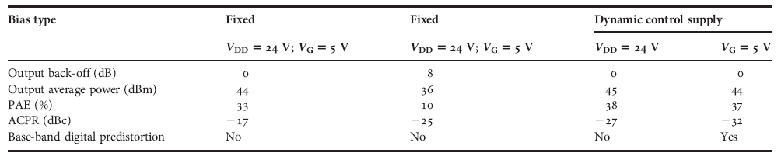
C) Figures

Figures may be line drawings or photographs and should be accompanied by a self- explanatory title and referred to consecutively as Fig. 1 etc. An example is shown in Fig.1

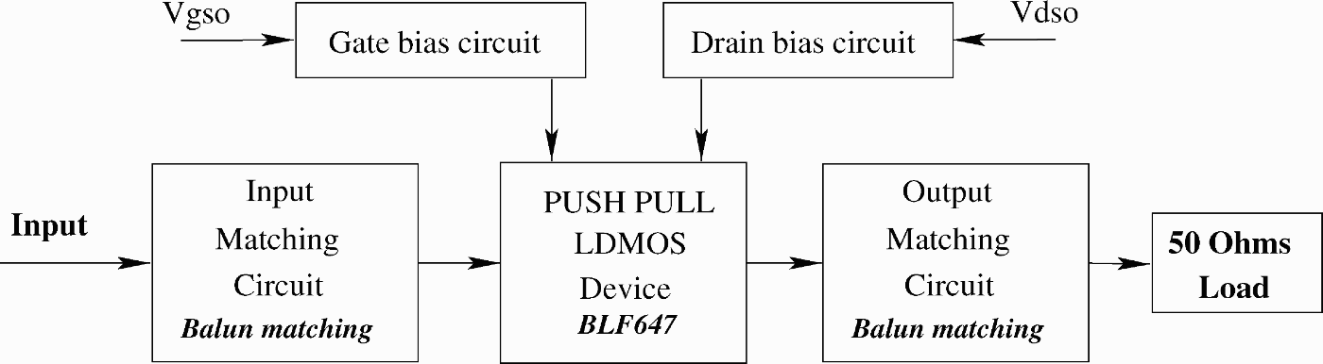

Fig. 1. Wide-band push–pull amplifier scheme.

Upon acceptance, individual figure files will be required in EPS or high-resolution TIFF format.

D) Citations

Citations in the text should be denoted as consecutive numbers in square brackets with one number per reference. For example, see the work of Author [1], Author and Other [2], and Author et al. [3]. Note that et al. is used in the citation, but the full reference in the references section should list all authors. Citations may also be inserted when the author is not being directly referenced [4], and multiple references should be indicated as, for example, [1,3] and [2 – 4].

E) Second-level headings

As shown in this document, first-level headings should be numbered I, II, III, etc. Second- level headings should then be lettered, as per this section.

1) Third-level headings
As indicated here, third-level headings should be numbered 1), 2), 3), etc.

IV. CONCLUSION

As mentioned above, all papers should close with a conclusion section.

V. REQUIRED SECTIONS

A) Acknowledgements

You may acknowledge individuals or organisations that provided advice, support (non-financial). Formal financial support and funding should be listed in the following section.

B) Financial Support

Please provide details of the sources of financial support for all authors, including grant numbers. For example, “This work was supported by the Medical Research Council (grant number XXXXXXX)”. Multiple grant numbers should be separated by a comma and space, and where research was funded by more than one agency the different agencies should be separated by a semi-colon, with “and” before the final funder. Grants held by different authors should be identified as belonging to individual authors by the authors’ initials. For example, “This work was supported by the Wellcome Trust (A.B., grant numbers XXXX, YYYY), (C.D., grant number ZZZZ); the Natural Environment Research Council (E.F., grant number FFFF); and the National Institutes of Health (A.B., grant number GGGG), (E.F., grant number HHHH)”. Where no specific funding has been provided for research, please provide the following statement: “This research received no specific grant from any funding agency, commercial or not-for-profit sectors.”

C) Conflict of interest

Please provide details of all known financial, professional and personal relationships with the potential to bias the work. Where no known conflicts of interest exist, please include the following statement: “None.”

D) Ethical standards

Where research involves human and/or animal experimentation, the following statements should be included (as applicable): “The authors assert that all procedures contributing to this work comply with the ethical standards of the relevant national and institutional committees on human experimentation and with the Helsinki Declaration of 1975, as revised in 2008.” and “The authors assert that all procedures contributing to this work comply with the ethical standards of the relevant national and institutional guides on the care and use of laboratory animals.”

REFERENCES

[1] Author, F.A.: Title of a journal article. Wireless Power Tech., 1 (2014),
911–999.

[2] Author, F.A.; Other, A.N.: Title of a Book, Cambridge University Press, Cambridge,
2009.

[3] Author, F.A.; Other, A.N.; Bloggs, J.O.E.: Title of a conference paper, Name of conference, Location, 2010.

[4] Writer, A.: Title of a book chapter or section, in Title of book, Cambridge University
Press, Cambridge, 2010, 1001 – 1013.

APPENDIX

If an appendix is required, it should go here, after the references.

Bibliographies (no more than 150 words each, accompanied by a 75 x 88 pixel photo)

First A. Author received a degree in physics from the University of A in 1998 and received his Ph.D. degree in communication engineering in 2002. He now holds a research chair at the B institute. His main research interests are design and optimization of high power microwave power amplifiers.


Second Author received her Diploma in 1997 from the University of C and received her Ph.D. at the D University in 2001. She became a full university professor in
2009. She is currently serving as chair of the E project and is active in the study of Si power electronics.

Third Author received his Ph.D. in 1988 from the Physics department of the F University. He was awarded a fellowship by the G institute of H in 1999 and has been working at the University of I since 2002. He has authored more than 100 research articles
and his current research interests include linear and non-linear CAD techniques and low noise receivers.

List of figures and tables

Fig. 1. Wide-band push–pull amplifier scheme.
Table 1. Measured performances in different operating conditions.

Author Language Services
We suggest that authors whose first language is not English have their manuscripts checked by a native English speaker before submission. This is optional but will help to ensure that any submissions that reach peer review can be judged exclusively on academic merit. We offer a Cambridge service which you can find out more about here, and suggest that authors make contact as appropriate. Please note that use of language editing services is voluntary and at the author’s own expense. Use of these services does not guarantee that the manuscript will be accepted for publication nor does it restrict the author to submitting to a Cambridge-published journal.

Amended February 2018

