USING THE MRS ADVANCES MANUSCRIPT FORMATTING TEMPLATE
First, save the attached template where you will be able to find it. The following steps should be used to attach the template to your manuscript:
- Open the document that needs a new template attached (your manuscript).

2. From the File tab menu, choose the Options command.

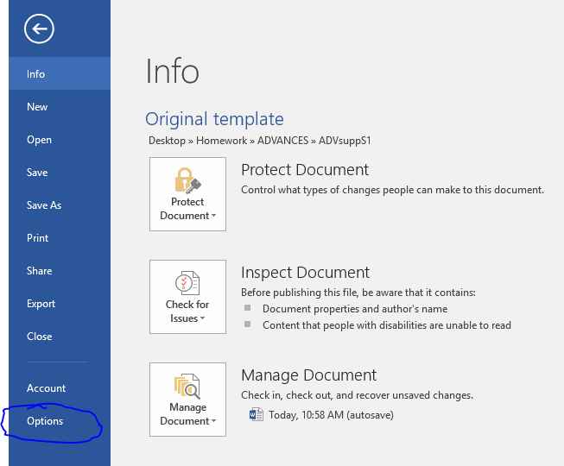

3. Choose Add-Ins in the Word Options dialog box.

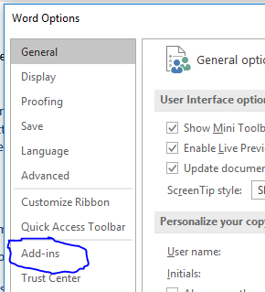

4. Select Templates from the Manage drop-down list.

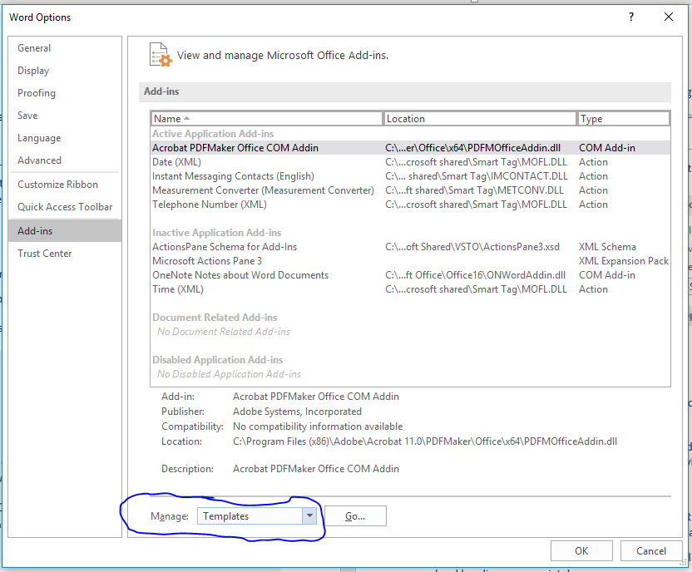

5. Click the Go button.

6. Click the Attach button.

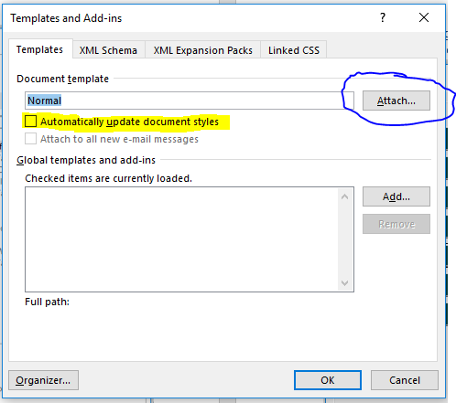

7. Select the template you have saved previously and click the Open button.

8. Select Automatically Update Document Styles (see highlight above).

9. Click OK.

You will now see a variety of element buttons in a box named “Camera Ready Styles.” Highlight the element you want to format and click the appropriate button (Article Title, Author, Abstract, etc.). You will notice that the template allows you to do only one affiliation, one paragraph, etc. at a time.
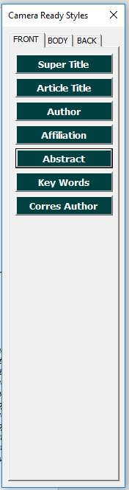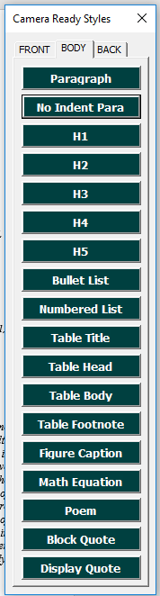
Please use Figure Caption for table captions, as well. Take care with headings and apply first and second level headings appropriately.
For example, in the list below the Roman numeral headings are H1 and the lettered items are H2 headings.
- INTRODUCTION
- Materials and Methods
  - Sample preparation
  - Characterization

When you have completed formatting, please submit the Word version of your paper to https://mc.manuscriptcentral.com/mrsadv.

