Instructions for Contributors to the
International Journal of Microwave and
Wireless Technologies

First A. Author¹, Second Author^{1,2}, Third Author²

- Cambridge University Press, Edinburgh Building, Shaftesbury Road, Cambridge, CB28RU, United Kingdom

- XLIM – CNRS 123, Avenue Albert Thomas, 87060 Limoges Cedex, France.

This file provides instructions for authors submitting papers to IJMWT, and is available in Microsoft Word and PDF formats as well as a LaTeX file (all files can be found at: https://www.cambridge.org/core/journals/international-journal-of-microwave-and-wireless-technologies/information/instructions-contributors). These instructions are also arranged in the style of a submitted paper, so either the Word or LaTeX file can also be used as a template for submissions. As all accepted papers will be imported into typesetting software by Cambridge University Press, there is no need for authors to spend unnecessary time formatting their paper to match the appearance of the final published article. However authors must follow rules expressly specified in this document (such as how references should be formatted). All papers must include an abstract, which should be a single paragraph not exceeding 200 words providing a short summary of the main aims, results and conclusions in such a way that it highlights the importance of the paper to the wider community, not only to experts in the subject.

Keywords: Authors should not add keywords, as these will be chosen during the submission process (see http://journals.cambridge.org/data/relatedlink/MRF_topics.pdf for the full list)

Corresponding author: F. A. Author; email: author@email.com;

I. INTRODUCTION

The International Journal of Microwave and Wireless Technologies publishes original papers on all aspects of microwave and RF research including applied electromagnetic theory, components, analogue and mixed-signal circuits, systems, optical-microwave interactions, electromagnetic compatibility, industrial applications, biological effects and medical applications. The journal encourages the submission of three types of paper, described below.
Note that all papers should begin with an ‘Introduction’ section and finish with ‘Conclusions’.

A) Research Articles - These papers describe new results in the field of microwave and wireless technologies.

B) Survey papers – These papers contain surveys of industrial developments in the field.

C) Review Articles - These papers provide comprehensive high-level tutorials on particular topics or overviews of the status of research and development on particular topics.

II. SUBMISSION

To submit a paper, go to the submission page at:

http://mc.manuscriptcentral.com/cup/mrf

You can then log in if you already have an account, or register a new account if you have not used the site before. Once logged in you will be able to click on the ‘Author Center’ link and follow the online instructions to proceed with your submission. Before submitting your paper, please make sure that you have read the remainder of these instructions.

All manuscripts submitted to the journal will be checked by iThenticate Plagiarism Detection Software. This software will compare the submitted manuscript with a large database of content items in order to help prevent misconduct in our journal.

A) Original Work
Submission of a manuscript implies that it has been approved in its final form by all the named authors, that it reports on unpublished work and that it has not been published or submitted for publication, in whole or in part, elsewhere. It is the responsibility of the corresponding author to ensure that these conditions are fulfilled.

B) Copyright
Authors of articles published in the journal assign copyright to Cambridge University Press and the European Microwave Association (with certain rights reserved), and a copyright assignment form must be completed on acceptance of your paper.

C) ORCID
IJMWT strongly encourages all corresponding authors to identify themselves using ORCID when submitting a manuscript to the journal. ORCID provides a unique identifier for researchers and, through integration in key research workflows such as publication and grant applications, provides the following benefits:

- Discoverability: ORCID increases the discoverability of your publications, by enabling smarter publisher systems and by helping readers to reliably find work that you've authored.

- Convenience: As more organisations use ORCID, providing your ID or using it to register for services will automatically link activities to your ORCID profile, and will save you re-keying information multiple times.

- Keeping track: Your ORCID profile is a neat place to record and display (if you choose) validated information about your research activities.

If you don't already have an ID, you can create one during submission to IJMWT. You can register for one directly from your user account on ScholarOne or via https://orcid.org/register. If you already have an ID, please use this when submitting by linking it to your ScholarOne user account. For ScholarOne: Simply log in to your account using your normal username and password. Edit your account by clicking on your name at the top right of the screen and from the dropdown menu, select 'E-Mail / Name'. Follow the instructions at the top of the screen to update your account.

D) File Formats
Papers should be prepared in either Microsoft Word or LaTeX format, and initially should have figures and tables embedded. If the paper is prepared in Word, the doc file can be uploaded during submission, and the submission system will generate a PDF for review purposes. If the paper is prepared in LaTeX, the author must generate a PDF and upload this during the submission process. If a paper is accepted for publication, the author will be required to complete a final stage of submitting the original source files (ie individual figure files, and either the Word file or LaTeX file as appropriate).

E) Keywords/topics
Please note that during submission authors will be required to select two keywords/topics from the list provided (see http://journals.cambridge.org/data/relatedlink/MRF_topics.pdf). Authors may also add a third keyword of their own if desired.

III. MANUSCRIPT FORMAT

A) Equations
Equations should be numbered consecutively as (1), (2), (3) etc. and, where necessary, referred to as such in the text. If you are preparing your paper in Word, equations can be set using MathType or Equation Editor, but should not be embedded as figures. See equation (1) for an example.

p
f_{i} ( x(k − _{τ} _{i} )) = ∑_{α} _{pi} x(k − _{τ} _{i} ) | x(k − _{τ} _{i} ) ^{P} (1)
p=0

B) Tables
Tables should be headed by a self-explanatory title and referred to consecutively as Table 1 etc. Please see Table 1 as an example. Though tables can be embedded as figures in the initial submission, upon final acceptance authors must provide the source files for tables. Upon acceptance, individual figure files will be required in EPS or high-resolution TIFF format.

Table 1. Measured performances in different operating conditions.

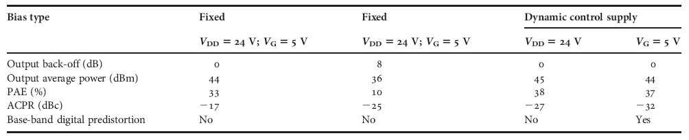

C) Figures

Figures may be line drawings or photographs and should be accompanied by a self- explanatory title and referred to consecutively as Fig. 1 etc. An example is shown in Fig.1 If you request colour figures in the printed version, you will be contacted by CCCRightslink who are acting on our behalf to collect Author Charges. Please follow their instructions in order to avoid any delay in the publication of your article.

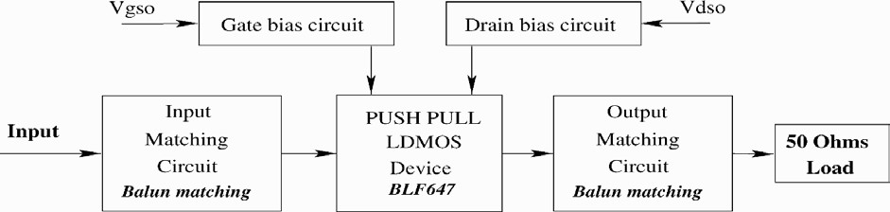

Fig. 1. Wide-band push–pull amplifier scheme.

D) Citations
Citations in the text should be denoted as consecutive numbers in square brackets with one number per reference. For example, see the work of Author [1], Author and Other [2], and Author et al. [3]. Note that et al. is used in the citation, but the full reference in the references section should list all authors. Citations may also be inserted when the author is not being directly referenced [4], and multiple references should be indicated as, for example, [1,3] and [2 – 4].

E) Second-level headings
As shown in this document, first-level headings should be numbered I, II, III, etc. Second- level headings should then be lettered, as per this section.

1) Third-level headings
As indicated here, third-level headings should be numbered 1), 2), 3), etc.

IV. CONCLUSION

As mentioned above, all papers should close with a conclusion section.

ACKNOWLEDGEMENT

This work was supported by the EU under project number AB01-2345-6789.

REFERENCES

- Author, F.A.: Title of a journal article. Int. J. Microwave and Wireless Tech., 1 (2009), 911–999.

- Author, F.A.; Other, A.N.: Title of a Book, Cambridge University Press, Cambridge,
2009.

- Author, F.A.; Other, A.N.; Bloggs, J.O.E.: Title of a conference paper, Name of conference, Location, 2010.

- Writer, A.: Title of a book chapter or section, in Title of book, Cambridge University Press, Cambridge, 2010, 1001 – 1013.

APPENDIX

If an appendix is required, it should go here, after the references.

Bibliographies (no more than 150 words each, accompanied by a 75 x 88 pixel photo)

First A. Author received a degree in physics from the University of A in
1998 and received his Ph.D. degree in communication engineering in 2002. He now holds a research chair at the B institute. His main research interests are design and optimization of high power microwave power amplifiers.

Second Author received her Diploma in 1997 from the University of C and
received her Ph.D. at the D University in 2001. She became a full university professor in 2009. She is currently serving as chair of the E project and is active in the study of Si power electronics.

Third Author received his Ph.D. in 1988 from the Physics department of the F
University. He was awarded a fellowship by the G institute of H in 1999 and has been working at the University of I since 2002. He has authored more than 100 research articles and his current research interests include linear and non-linear CAD techniques and low noise receivers.

List of figures and tables

Fig. 1. Wide-band push–pull amplifier scheme.
Table 1. Measured performances in different operating conditions.

Cambridge Language Editing Service
We suggest that authors whose first language is not English have their manuscripts checked by a native English speaker before submission. This is optional but will help to ensure that any submissions that reach peer review can be judged exclusively on academic merit. We offer a Cambridge service which you can find out more about here, and suggest that authors make contact as appropriate. Please note that use of language editing services is voluntary and at the author’s own expense. Use of these services does not guarantee that the manuscript will be accepted for publication nor does it restrict the author to submitting to a Cambridge-published journal.

Gold Open Access

You will have the option to publish your article as Gold Open Access, enabling the final published version to be made freely available under a Creative Commons license. You might be required to pay an Article Processing Charge (APC) for Gold Open Access. You may be eligible for a waiver or discount, for example if your institution is part of a Read and Publish sales agreement with Cambridge University Press. For more information about your Open Access options, please see here. For more information about the benefits of choosing to publish Open Access, see here.

