Electronic Figure Guidelines

*Paleobiology*

Requirements at a Glance

Figure File Details

Figures for Review

* For review, figures may be submitted in any file type (.jpg, .tif, .eps, .pdf, etc.) as long as they show up in the review pdf.
* If submitting a pdf, please ensure it is at a 1- or 2-column size.
* Please ensure that the file size is small enough to create an image in the PDF proof. This means your image must be less than 40 megapixels (i.e., the total number of pixels [height x width] has to be <40 megapixels). Your figure must have enough detail for reviewers to examine necessary features, however.

Figures for Production (Table 1)

* If your manuscript has been accepted for publication, you will be asked to upload your final figures.
* Only .tif or .eps files will be accepted for Production.
* Please label production figures with 1- or 2-column (e.g., Figure1_1col.tif; Figure2_2col.eps) to indicate final size.
* Please ensure that your figures are saved at final publication size and are in an accepted file format. Failure to supply figures in the proper size and/or format will delay publication of your paper.
* To ensure that your figures are reproduced to the highest possible standards, Cambridge Journals requires the formats and resolutions listed in Table 1 for electronic figures.

Column Sizes

* 1 column= 9 cm wide.
* 2 columns= 18 cm wide.
* Full page= 18 cm wide, 24 cm long.

Note Regarding Large Image Files

Please save large image files (full-resolution files for production) with LZW compression to ensure they can be uploaded correctly. LZW compression reduces file size (sometimes drastically) without affecting quality. LZW compression is also reversible. LZW compression is an option when you save a file from a graphics package (such as Photoshop) using the menu option “Save as,” then selecting TIFF format, saving, then selecting LZW compression in the following window.

IrfanView is a graphics program that you can download for free for PCs that will allow you to use LZW compression. You can download the program at a number of locations on the web, including http://www.tucows.com/preview/19496

Photo Requirements

* Photos must not be altered except for tone, contrast and the addition of labels or outlines of features.
* Specimens are illuminated obliquely from the upper left unless photographed in situ.
* Specimens are oriented following standard practice for the taxonomic group.
* Key features are clearly visible.

Figure Labels, Text, and Scale

* Subfigures labels should be capital letters (A, B, C…), in the upper left or right corner of each image.
* Labels and text used in figures must be sans serif (e.g., Arial font), consistent in size and style through a figure or figures of similar type (such as graphs), and readable.
  + Minimum font size in figures is 8 point at final size.
  + Minimum line weight is 0.3 point (0.11 mm) at final size.
  + Prominent line (e.g. plot lines on graphs) weight should be 0.75 to 1.0 point (0.25 to 0.35 mm).
* Scale bars are required in photographs of specimens. Field photographs may use rulers or an object with a known size for scale. A numerical description of scale bar size should be included either with the scale bar or in the caption. Explanations of magnification (such as X40) cannot be used because figures may be resized in final print. Scale bars should be of uniform thickness.
* Maps and stratigraphic columns must include a sense of scale, such as a scale bar or latitude/longitude.
* The figure is explained in the caption in telegraphic style.
* All subfigures and abbreviations used in the figure must be explained in the caption. Abbreviations used in multiple figures must be explained in each figure’s caption or reference another caption where they are explained.
* The method used to generate the figure is explained in the caption (equations, assumptions, cited in text, etc.).

Helpful Hints

* Please generate or convert directly to the dpi resolution from native software programs, such as Photoshop (psd), Adobe Illustrator (ai), Coreldraw (cdr), Corel PhotoPaint (cpt).
* Do not simply resample/upsample an existing image file (.jpg, .tiff, etc) from low resolution (e.g., 300 dpi) to higher resolution (e.g., 600 dpi) because this does not help improve the true quality or resolution of an image.
* On ScholarOne, large files may take several minutes to upload. Large figure files may not convert after upload—this is normal, and the final files will be transmitted to Production. If you have problems uploading your final files, please contact the Managing Editor at: [paleobiology@cambridge.org](mailto:paleobiology@cambridge.org)

Table 1. Cambridge Production Requirements.

|  |  |  |  |  |
| --- | --- | --- | --- | --- |
|  | **Definition** | **Format** | **Requirements** | **Examples** |
| Line Artwork | Black and white or colour graohics with no fine shading | Any format accepted (.eps, .tiff, .jepg, .png, .pdf)  Colour mode:   * Black and white (aka 1-bit) * CMYK colour   Resolution: 1200dpi | All lines should be at least 0.11 mm (0.3 pt) wide.  Vector graphics containing fonts must have fonts embedded in the files. | Line graphs.  Black and white drawings (stippling OK, no detailed shading)  Maps with blocks of color or shades of gray |
| Combination Artwork | Halftone (see below) with line drawings, extensive lettering, shaded diagrams etc. | Any format accepted (.eps, .tiff, .jepg, .png, .pdf)  Colour mode:   * Grayscale (aka 8-bit) * CMYK colour   Resolution: 800dpi |  | Combination of photos or artistic artwork with extensive lettering or lines. |
| Halftone Artwork | Photographs or artistic drawings with fine shading. | Any format accepted (.eps, .tiff, .jepg, .png, .pdf)  Colour mode:   * Grayscale (aka 8-bit) * CMYK colour   Resolution: 600dpi | If magnification is used in the photographs, inidcate by using scale bars within the figures themselves | Color or back and white photographs.  Finely shaded artwork. |

Examples:

Line Artwork

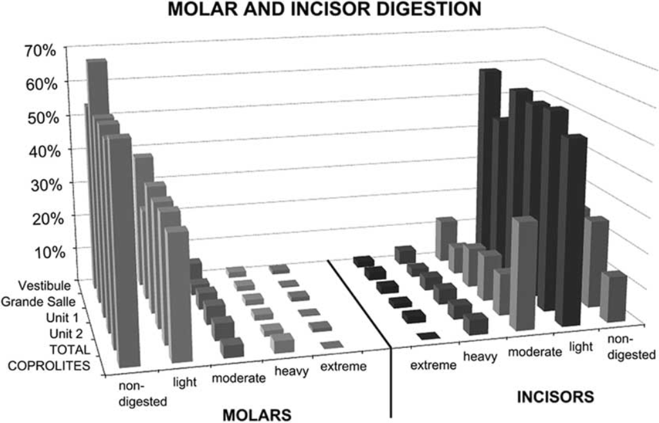 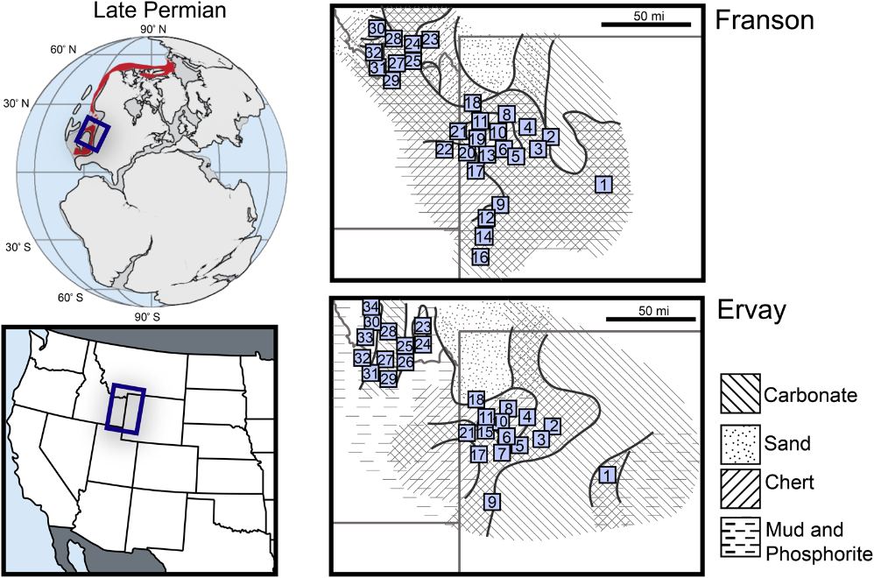

Block graph in shades of gray. Williams et al. Color maps with stippling, no fine shading.

2018: Fig 4. Wistort and Ritterbush 2022: Fig. 1.

Combination Artwork

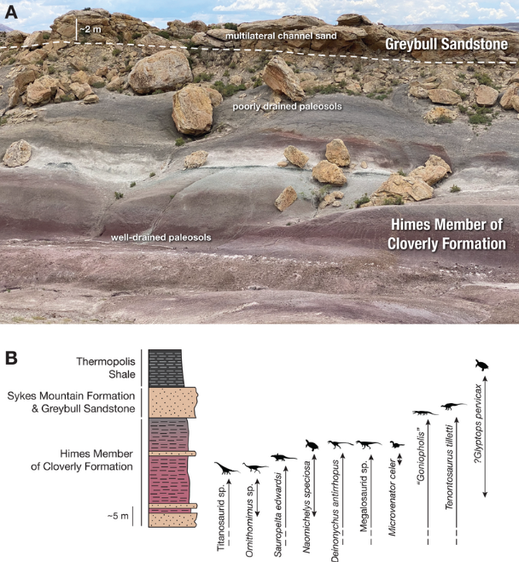 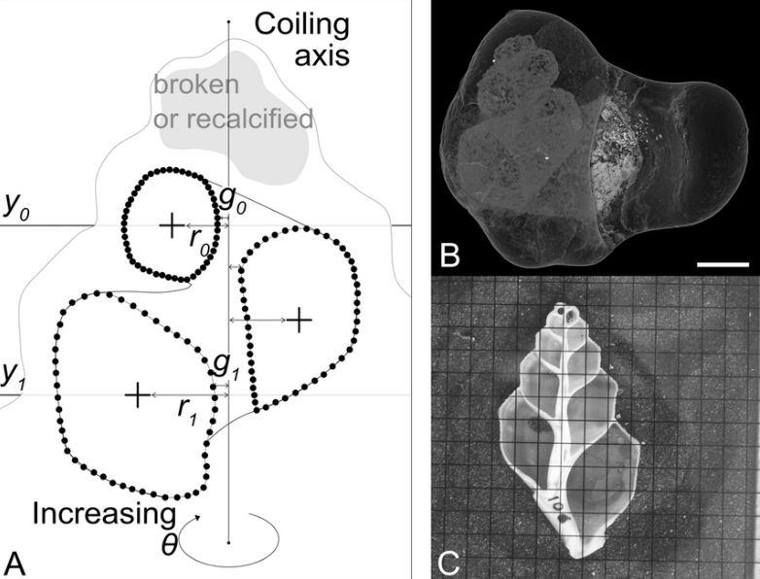

Field photo and stratigraphic column. Line drawing and computer images. Collins et al.

Holland 2022: Fig. 13. 2021: Fig. 3.

Halftone Artwork

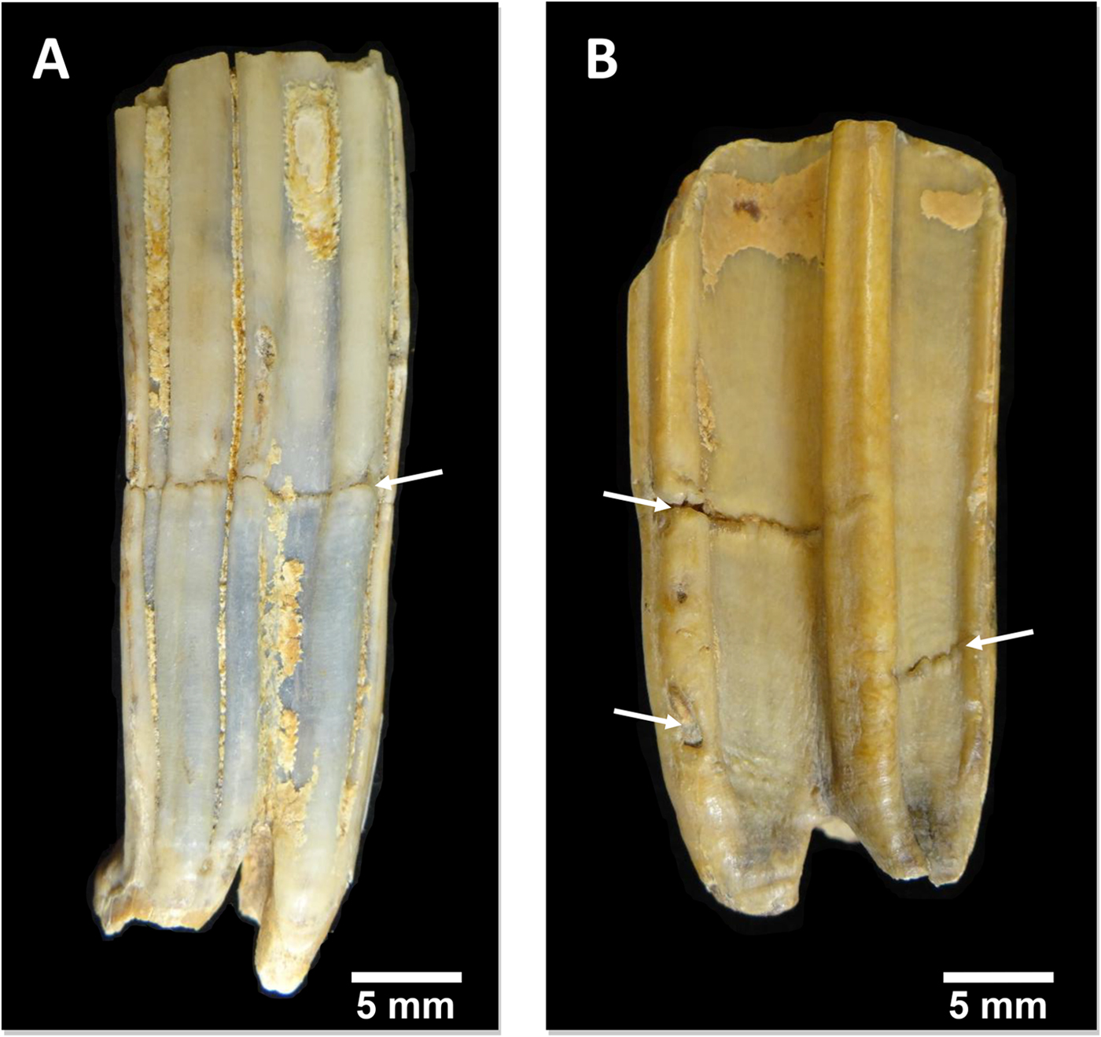 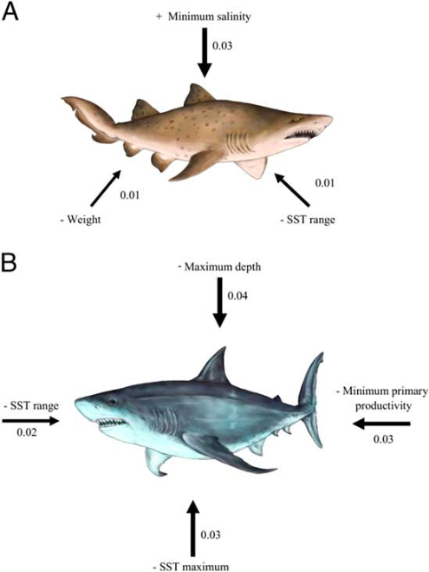

Specimen photographs. Barrón-Ortiz et al., Artistic drawings with fine shading.

2019: Fig. 4 Villafaña and Rivadeneira 2018: Fig. 3.

**Figure References**

Barrón-Ortiz, C. I., C. N. Jass, R. Barrón-Corvera, J. Austen, and J. M. Theodor. 2019. Enamel hypoplasia and dental wear of North American late Pleistocene horses and bison: an assessment of nutritionally based extinction models. Paleobiology 45:484–515.

Collins, K. S., R. Klapaukh, J. S. Crampton, M. F. Gazley, C. I. Schipper, A. Maksimenko, and B. R. Hines. 2021. Going round the twist—an empirical analysis of shell coiling in helicospiral gastropods. Paleobiology 47:648–665.

Holland, S. 2022. The structure of the nonmarine fossil record: predictions from a coupled stratigraphic–paleoecological model of a coastal basin. Paleobiology 48:372–396.

Villafaña, J. A., and M. M. Rivadeneira. 2018. The modulating role of traits on the biogeographic dynamics of chondrichthyans from the Neogene to the present. Paleobiology 44:251–262.

Williams, J., P. Andrews, S. García-Morato, P. Villa, and Y. Fernández-Jalvo. 2018. Hyena as a predator of small mammals? Taphonomic analysis from the site of Bois Roche, France. Paleobiology 44:511–529.

Wistort, Z. P., and K. A. Ritterbush. 2022. The effect of siliceous sponge deposition on Permian paleocommunity structure. Paleobiology doi: [https://doi.org/10.1017/pab.2022.18](https://url.avanan.click/v2/r02/___https://doi.org/10.1017/pab.2022.18___.YXAxZTpjYW1icmlkZ2Vvcmc6YTpvOjg5OTYzMjIzZDZmODk3OTQyMGE5MmQ1MDVlYWFjYzMxOjc6YzEzNzpmMmQ0ZGU2MzFhYjdlYjU2MmE2ZDg4MTBmOGUxN2Q5YTUxOGQwODExYWE5YjE2MjI5NTg4YTYzYWY3MDg1OGRhOnA6VDpG).

Last updated: 21/07/2025